**PREFACE**

* This project is developed for submission of Bachelor of Computer Application course. This project provides user the facility to book movie tickets in ARC Theater.
* In the making of this Website we used MySQL as backend-end tool, And PHP as front-end tool. MySQL is globally known for being the most secure and reliable database management system.
* As a student of BCA, we get opportunity to develop a Website for our 5th semester project.
* It also includes a dissertation to be submitted by each of the BCA student as a part of the curriculum.
* This project report is submitted as a part of the three years course of BCA
* BCA-V conducted by Bachelor of Computer Application from

Saurashtra University, Rajkot.

**ACKNOWLEDGEMENT**

* It is our pleasure to acknowledge you that we have taken a project on Online Movie Booking System.
* We are thankful to our PROF. Piyush D. Pitroda for giving us full guidance and co-operation in understanding the information system. We also thank them for their unconditional help in making of this project.
* We are also thankful to our family and friends for supporting us in every situation.
* Finally, we want to say thanks to all faculties of NCC (National Computer College) for helping us a lot.

**SHIKHALIYA PRATIK**

**JATIYA DHARMIK**

**SAURASHTRA UNIVERSITY**

The Saurashtra University is one of the most well-known universities.

It was established on 23rdmay, 1968. It was fairly reputed university in India conducting various courses regarding the dream of 21st century. The university in going day by day, this provides the student the courses level from the graduate to PH.D.

Shree Haribhai Trivedi and Shree Dolarbhai Mankad printthe title magazine in 1958 the resolution passed and 16 August, 1960.It was accepted in the 3rd five year plan of Gujarat, which is started in 1961-62. In 1965 December, the rules regarding university got the permission and 23 august, 1966 certain section is implementedby the result of Saurashtra University started.

The Saurashtra University works officially at 23 may, 1967. At the same time 35 colleges and 2 permitted institutions were started Rajkot, Bhavnagar, Amreli, Junagadh, and Surendranagar districts. The total students were about 18000. Then in the same year two college sare permitted and 37 colleges existed.

**NATIONAL COMPUTER COLLEGE**

**Oppo. 4-Oswal Colony, Sundaram Society, Satyam Colony Road, Jamnagar.**

**Phone no. (0288) 2711338**

National Computer College is begun in year 2000. It is affiliated with Saurashtra University.

Two courses are available in National Computer College. They are Bachelor of Computer College (B.C.A), Bachelor of Business Administration (B.B.A).

As and when we surrounded by difficulties and problems, faculties always guide us and solve our problems. Our principal DR. DIPTI DOMADIYA always inspired us to go ahead though in most difficult situations. The authority persons and all the staff members of National Computer College are good care taking and always helped us in any situation. Each and every subject is explained very easily and in detail so that student can understand very easily and in details so that students can understand very easily. The faculties associated with the college are very helpful &co-operative.

*Staff of National Computer College*

Principal: Dr. Dipti Domadiya

Faculties: Dr. Hasmukh Domadiya

Prof. Chirag Mehta

Prof. Piyush Pitroda

Prof. Rohit Pambhar

Prof. Tushar Sheth

**System Development Life Cycle**

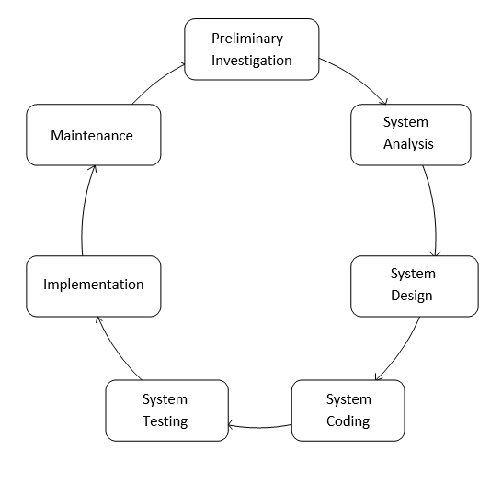

**Software Used**

* **Frontend:**
* PHP
* **Backend:**
* MySQL
* **OS:**
* Windows 7 Ultimate

About PHP

* Introduction to PHP:
* The full form of PHP is “hypertext pre-processor”. Its original name was “personal home page”.
* Rasmus leadorf software engineer, apache team member is the creator and original driving force behind PHP. The first part of PHP was developed for his personal use in late 1994.
* By the middle of 1997, PHP was being used on approximately 50,000 sites worldwide.
* PHP costs you nothing. It is open source language and doesn’t need to purchase it for development.
* PHP is server-side scripting language, which can be embedded in HTML or used as a stand-alone.
* PHP is an official module of Apache HTTP server.
* PHP is fully cross-platform, meaning it run snativeon several flavors of UNIX, as well as on windows and now on Mac OSX.
* PHP is easy to learn, compared to the others. A lot of ready-made PHP scripts are freely available in market so, you can use them in your project or get some help from them.

**About MySQL**

* MySQL, the most popular open source SQL database management system, is developed, distributed, and supported by MySQL AB.
* MySQL AB is a commercial company, founded by the MySQL developers. It is a second generation open source company that unites open source values and methodology with a successful business model.
* The MySQL website (<http://www.mysql.com/>) provides the latest information about MySQL software and MySQL AB.
* The official way to pronounce “MySQL” is “My ESS QueEll” (not “my sequel”), but we don’t mind if you pronounce it as “my sequel” or in some other localized way.
* MySQL is a relational database management system.
* The MySQL RDBMS is very fast, reliable, and easy to use.

**About Apache WebServer**

* Apache web server is an open source web server creation, deployment and management software. Initially developed by a group of software programmers, it is now maintained by the Apache Software Foundation.
* As of 2013, with over 100 million websites and over 50 percent of the most commonly used applications for website hosting.
* So basically a web server is the software that receives your request to access a webpage. It runs a few security checks on your HTTP request and takes you to the web page. It then serves you the document you requested.
* A very long history of reliability and performance.
* Mass adoption means there is a lot of documentation out there and it is very easy to get help with trouble, you might run on it.
* It is one of the most feature rich web servers available.

**Data FlowDiagram**

* **Zero Level DFD(Context Level)**

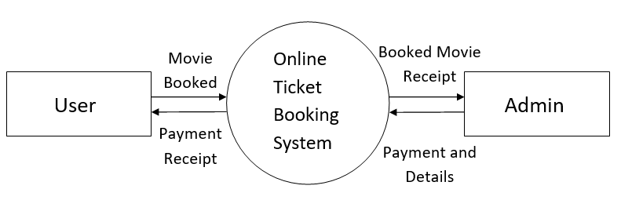

* **1stLevel DFD**

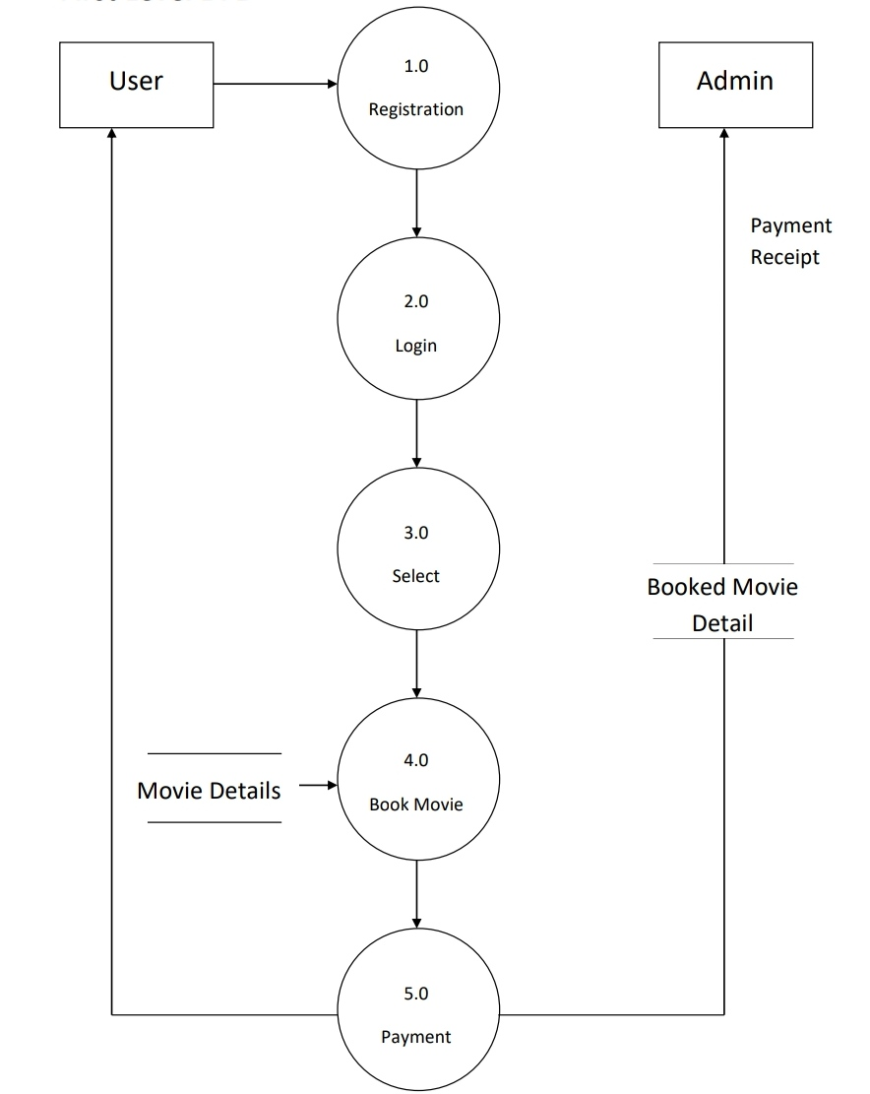

**Data Dictionary**

**Admin:**

|  |  |  |
| --- | --- | --- |
| Field | Type | Key Attributes |
| a_id | Int(12) | Primary Key |
| a_email | varchar(255) | - |
| a_pass | varchar(30) | - |

**Booking:**

|  |  |  |
| --- | --- | --- |
| Fields | Type | Key Attributes |
| Bookid | int(11) | Primary Key |
| movieName | varchar(255) | - |
| userName | varchar(255) | - |
| phoNo | varchar(10) | - |
| cardNo | varchar(16) | - |
| moviePrice | double | - |
| seatBooking | Int(12) | - |
| date | datetime | - |
| total | double | - |

**current_movie:**

|  |  |  |
| --- | --- | --- |
| Field | Type | Key Attributes |
| m_id | int(12) | Primary Key |
| m_name | varchar(255) | - |
| m_desc | text | - |
| seats | int(12) | - |
| price | double | - |
| m_img | varchar(255) | - |
| date | datetime | - |

**Feedback:**

|  |  |  |
| --- | --- | --- |
| Field | Type | Key Attributes |
| f_id | int(12) | Primary Key |
| name | varchar(255) | - |
| experince | varchar(255) | - |
| suggestion | text | - |

**Movie:**

|  |  |  |
| --- | --- | --- |
| Fields | Type | Key Attributes |
| m_id | int(12) | Primary Key |
| m_name | varchar(255) | - |
| m_des | text | - |
| m_img | varchar(255) | - |

**Slider:**

|  |  |  |
| --- | --- | --- |
| Fields | Type | Key Attributes |
| s_id | int(12) | Primary Key |
| s_img | varchar(255) | - |

**User:**

|  |  |  |
| --- | --- | --- |
| Field | Type | Key Attributes |
| uid | int(12) | Primary Key |
| name | varchar(255) | - |
| phno | varchar(10) | - |
| email | varchar(255) | - |
| pass | varchar(30) | - |

**Validation & Security**

* **Validations:**
  + The Password should contain only characters and numbers.User can’t include special characters.
  + For login into website users must have fill all the details.Because all the fills are mandatory.
* **Security:**
* Security is one of the special features of our website.
* Website will not allow you to access and of the administrative tools until you provide valid username and password.

**Site Map**

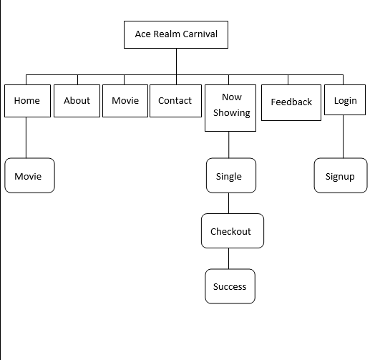

**Snapshots User site**

**index.php**

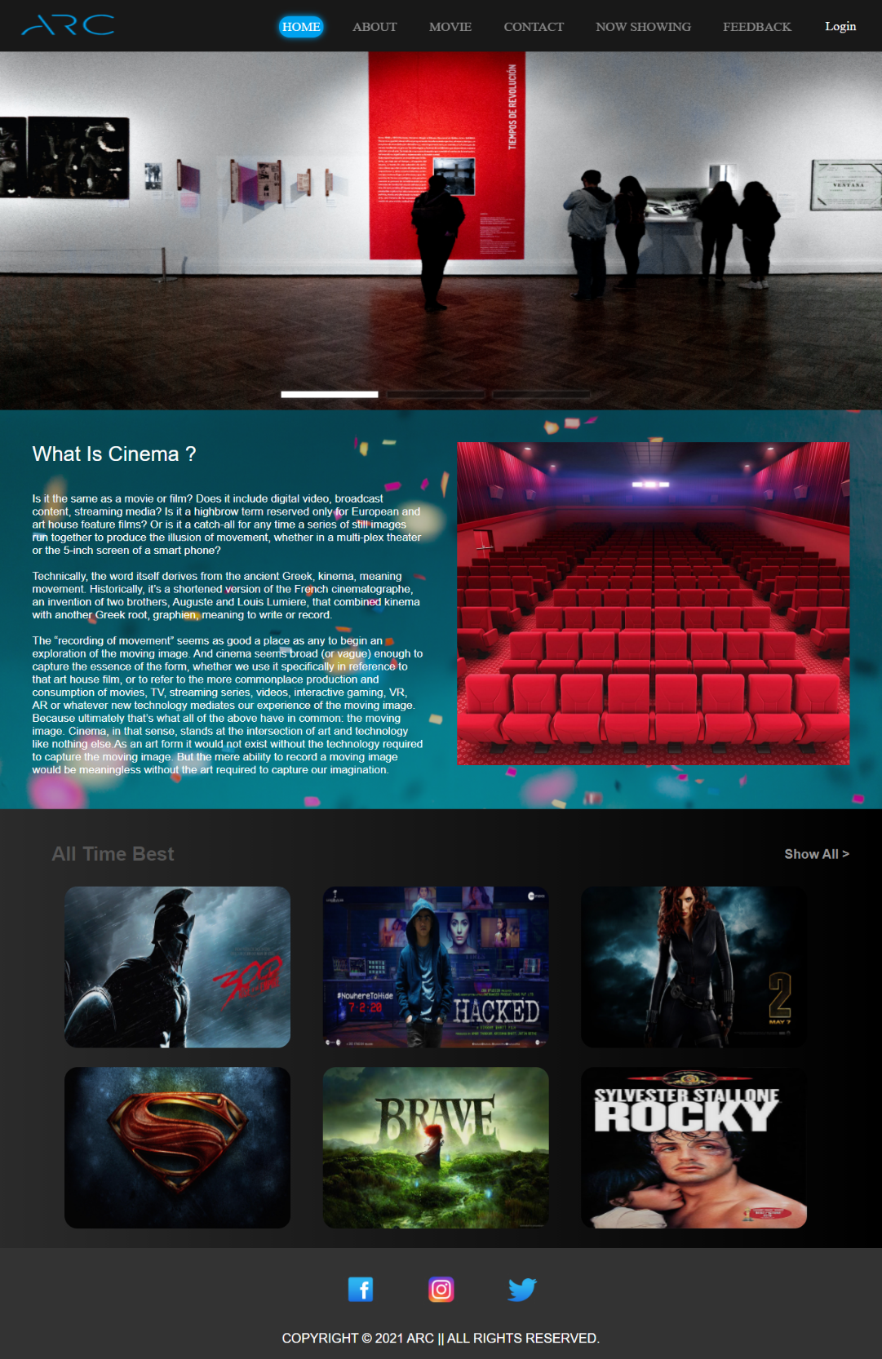

**About.php**



**Movie.php**

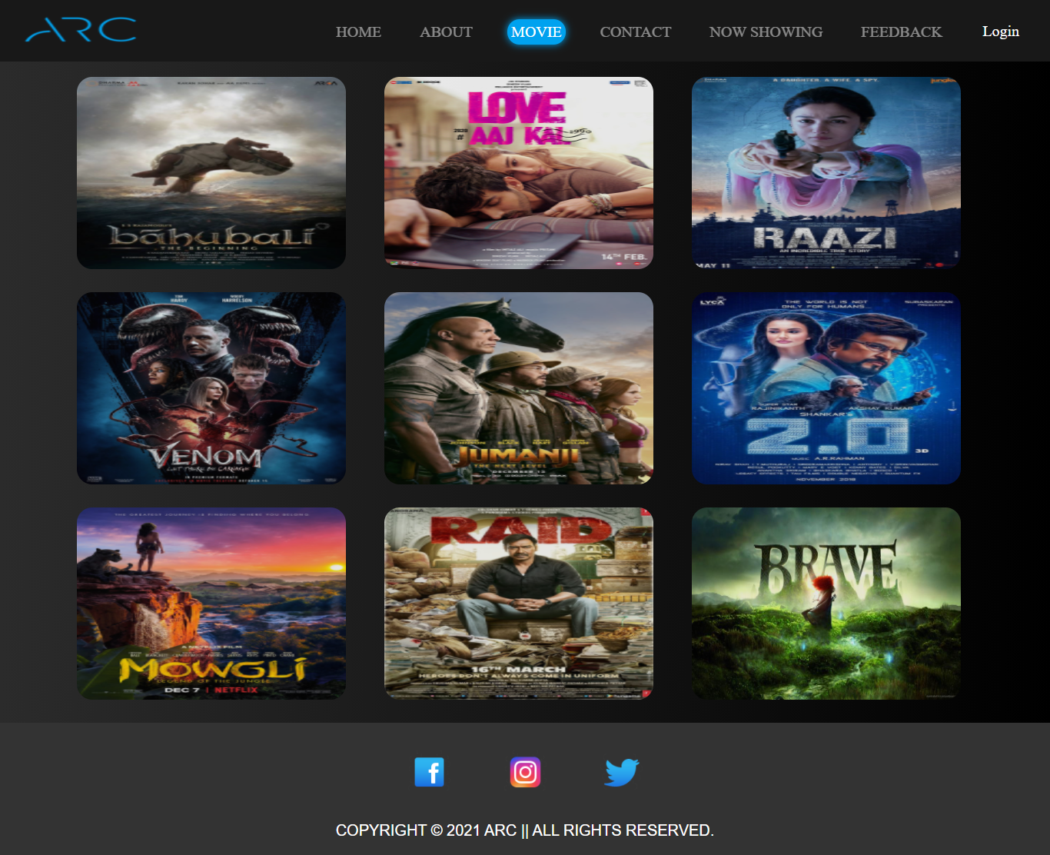

**Contact.php**

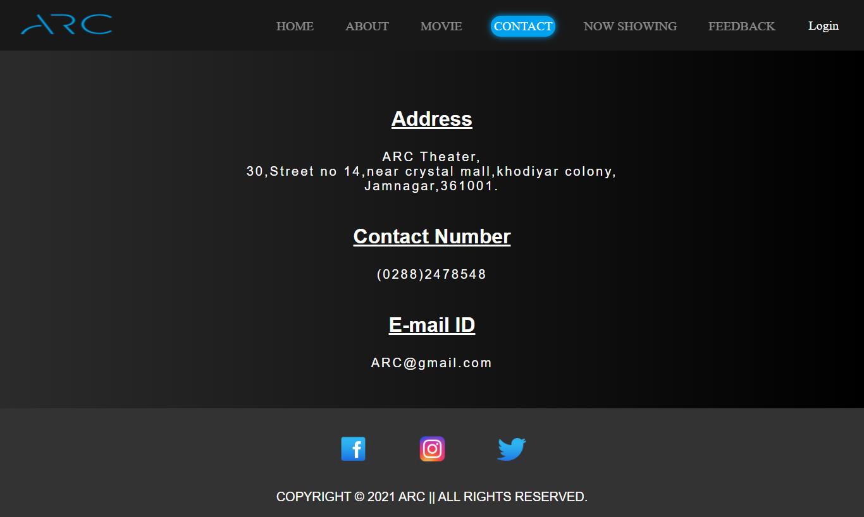

**Nowshowing.php**

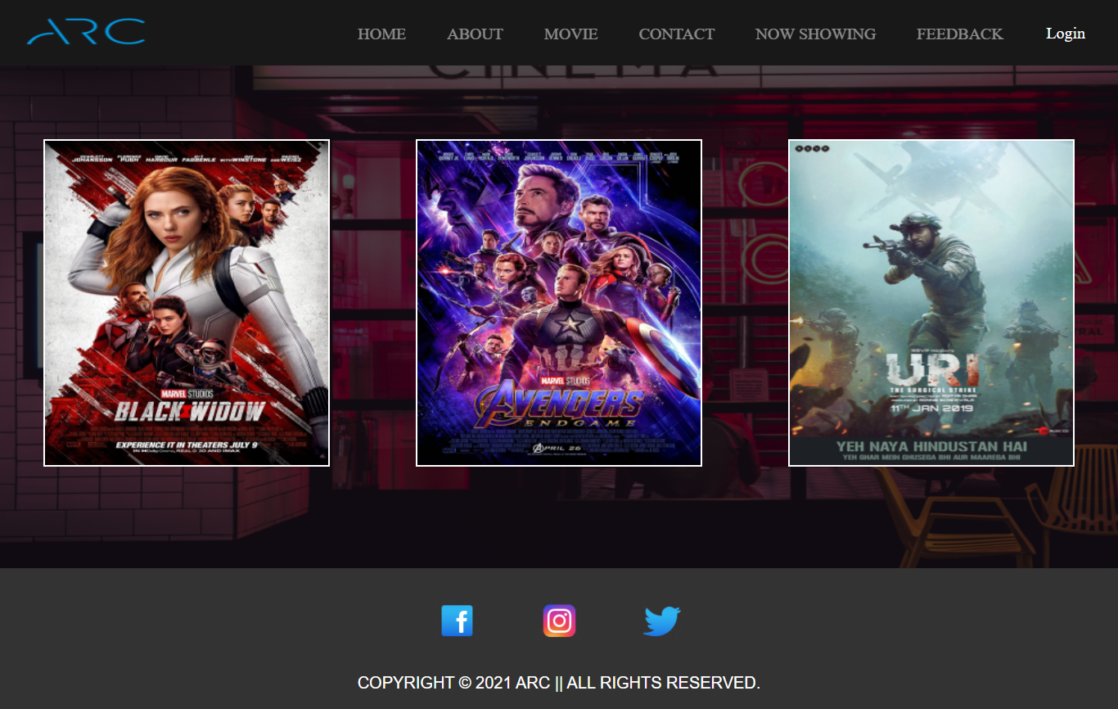

**Single.php**

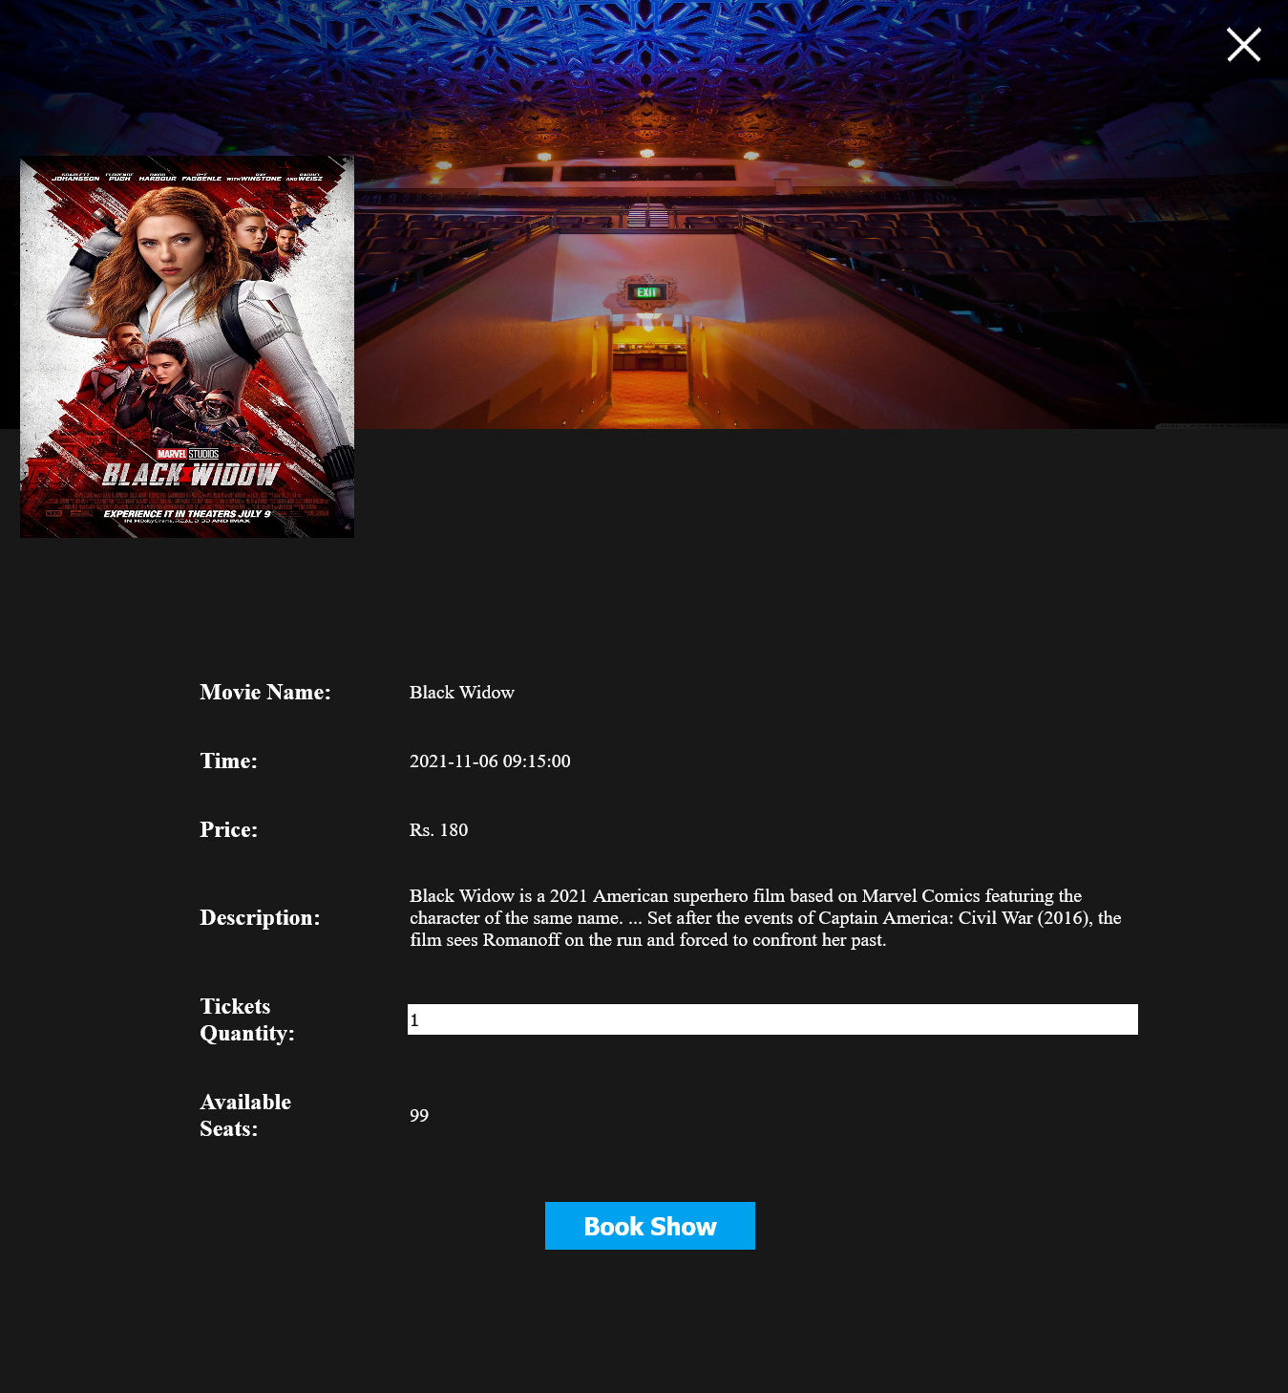

**Checkout.php**

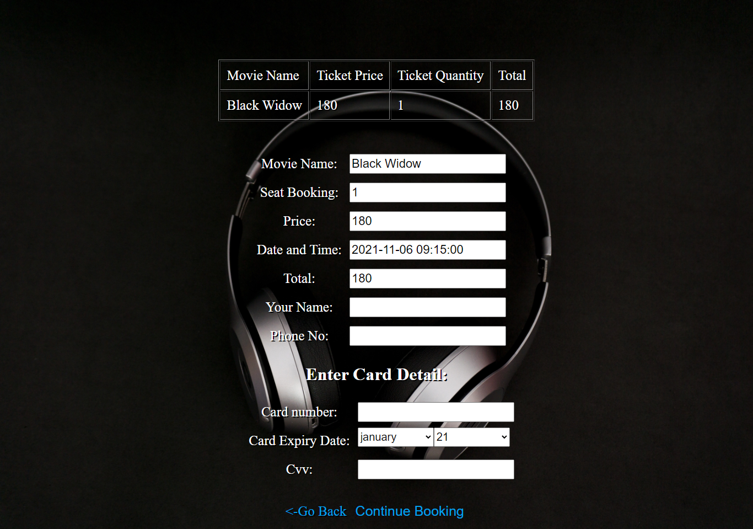

**Success.php**

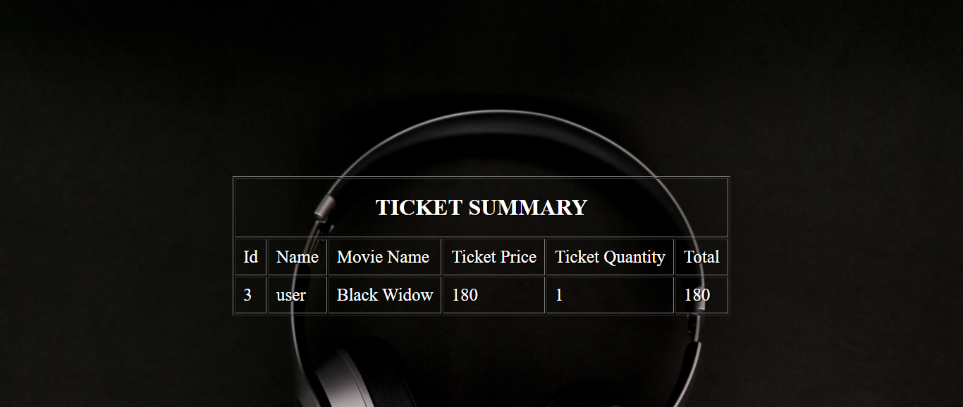

**Feedback.php**

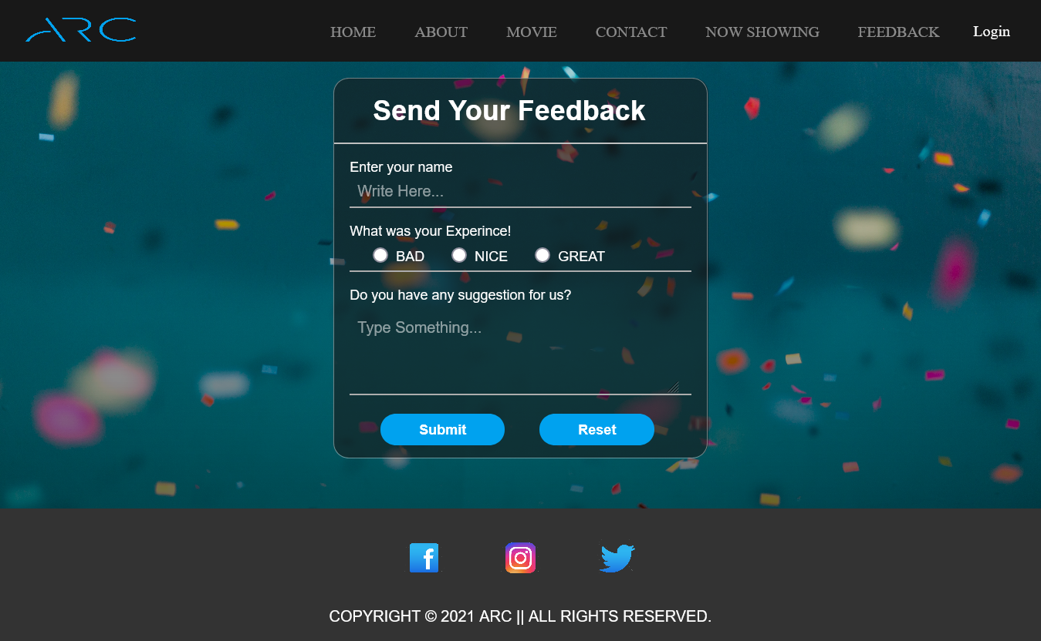

**Login.php**

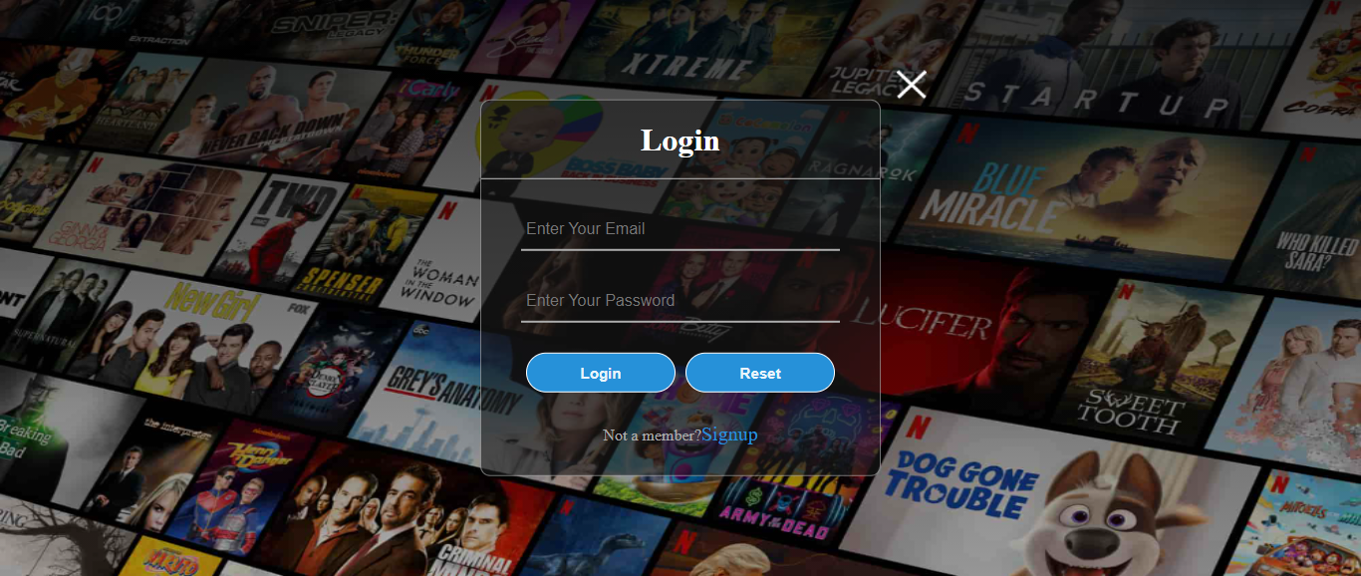

**Signup.php**

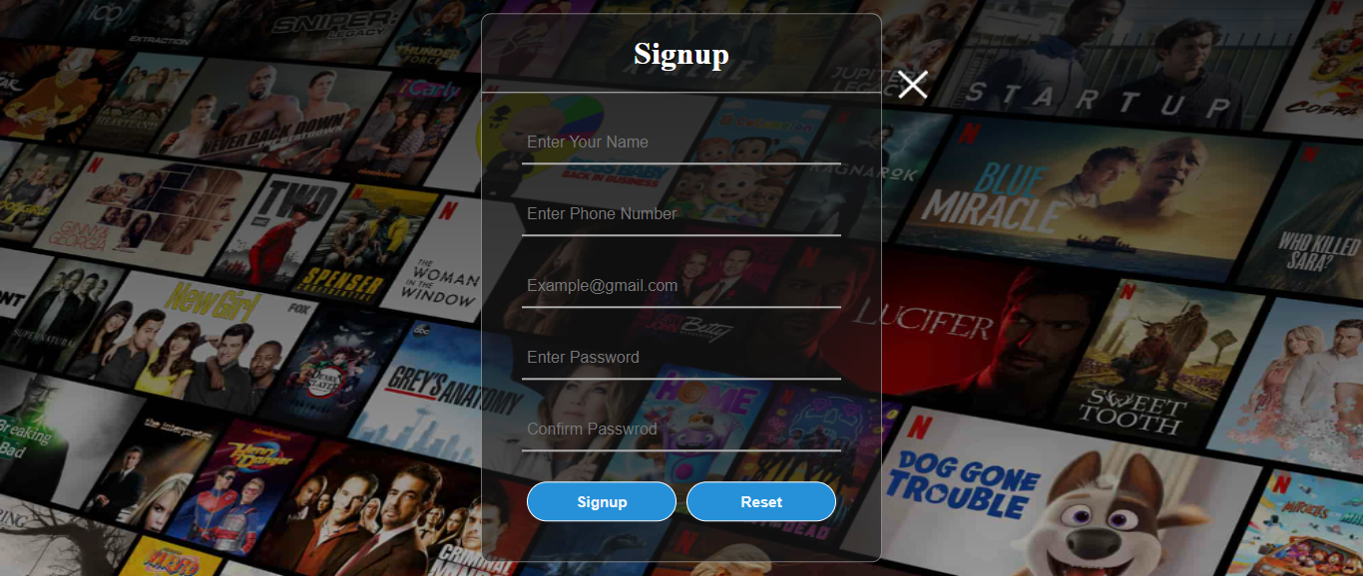

**Snapshots Admin site**

**Alogin.php**

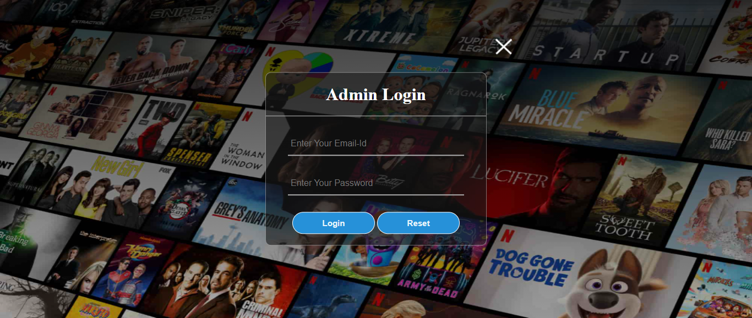

**Index.php**

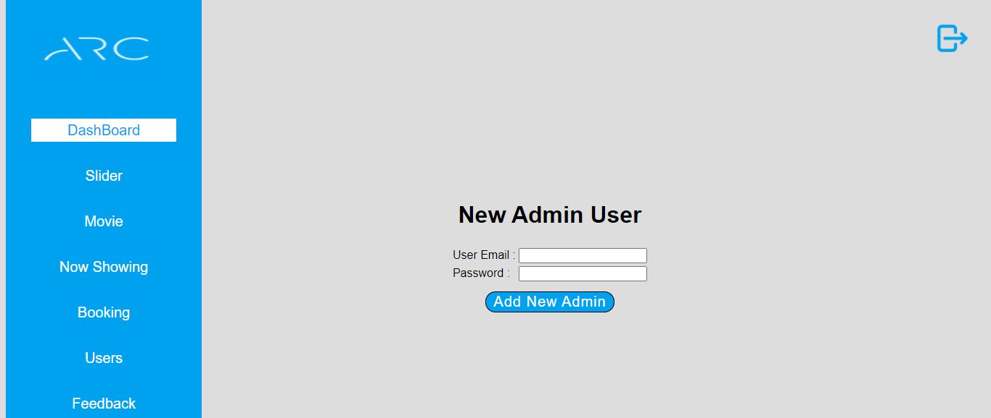

**Listslider.php**

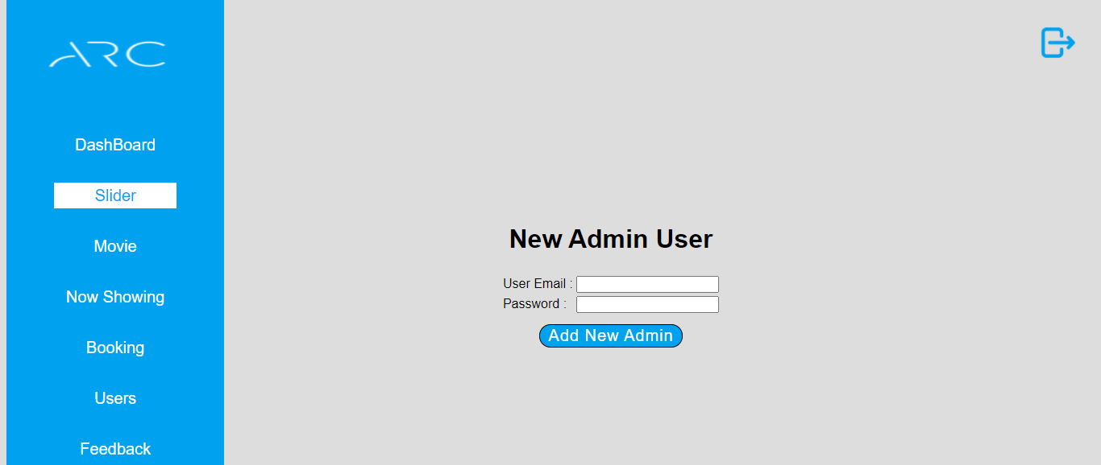

**Listmovie.php**

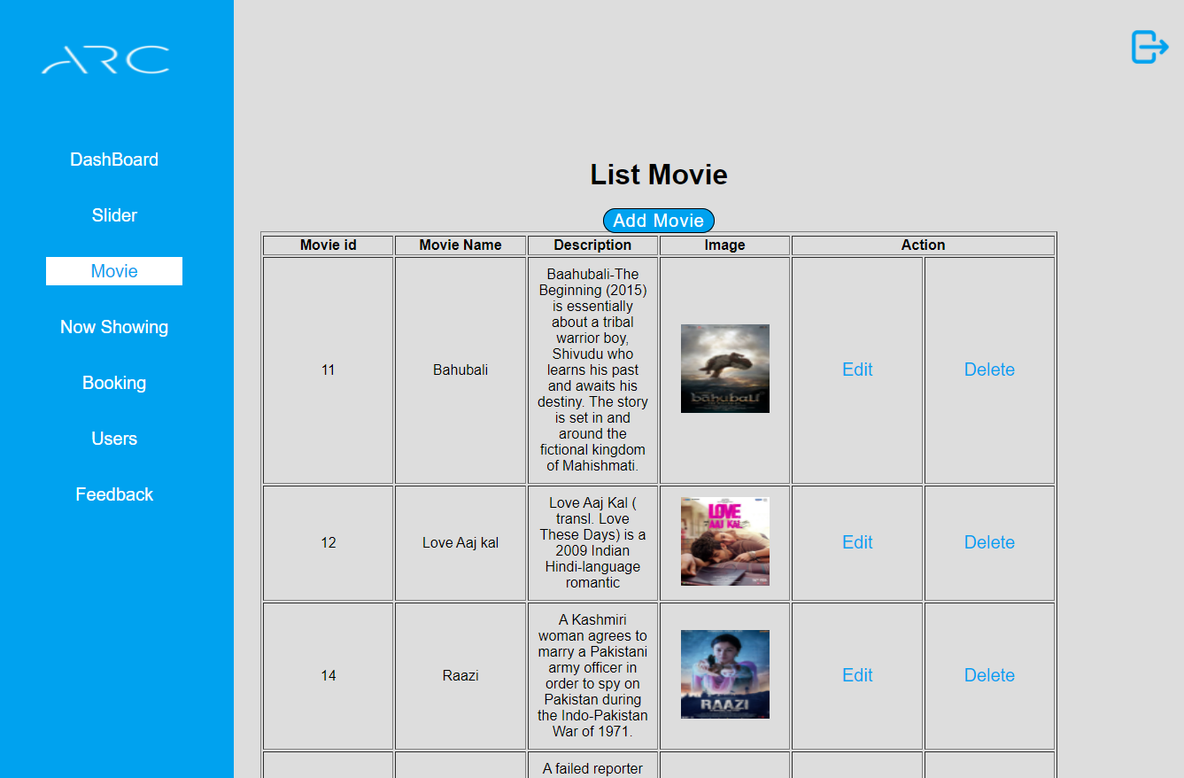

**Addeditmovie.php**

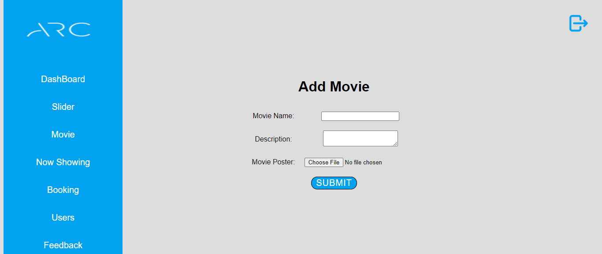

**Listcmovie.php**

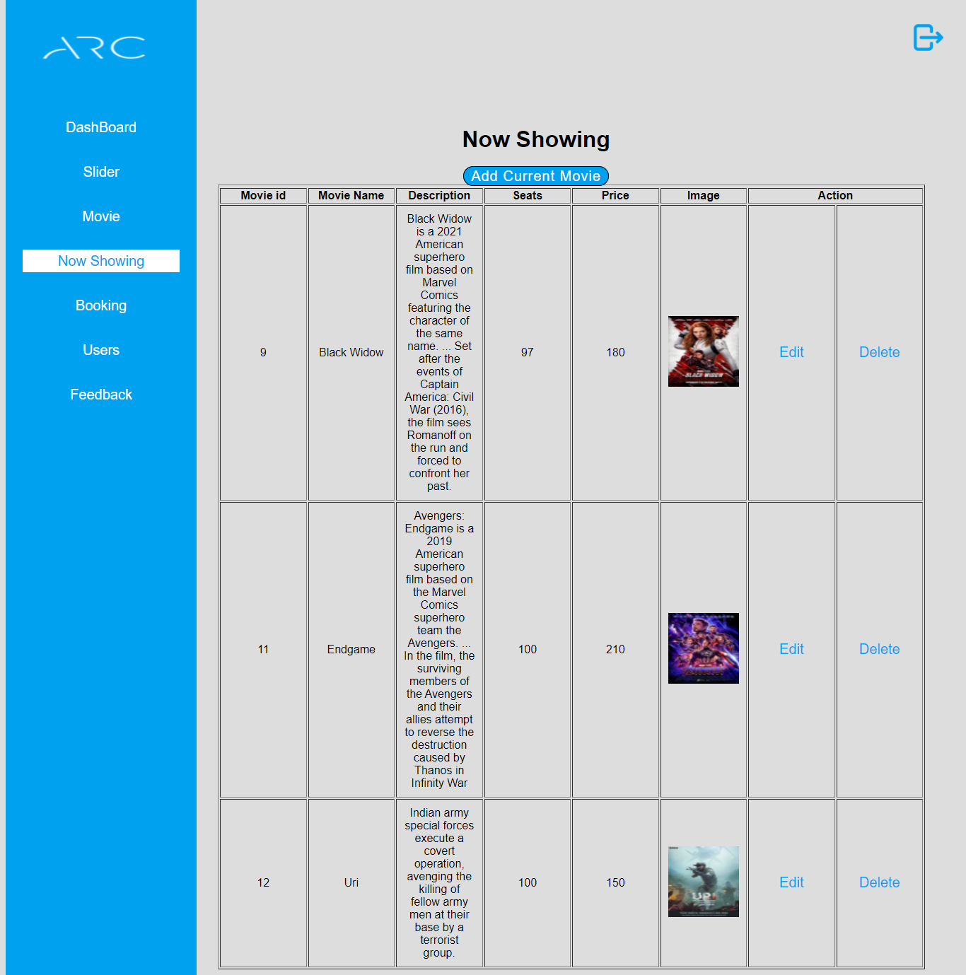

**Addeditcmovie.php**

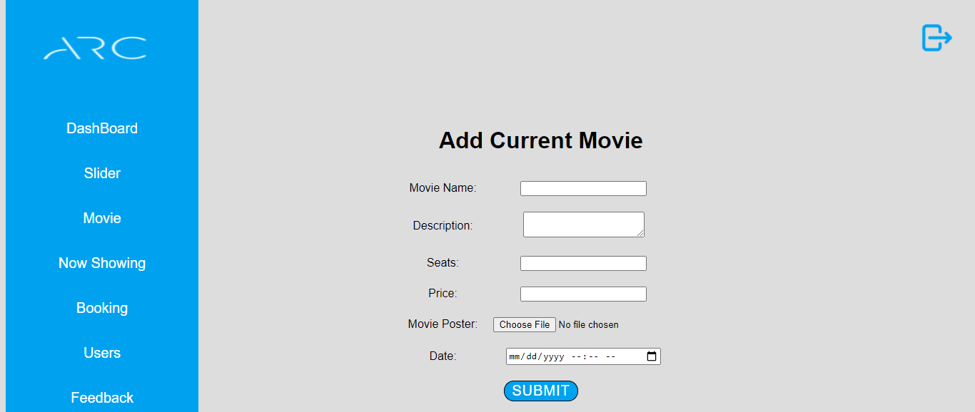

**Listbooking.php**

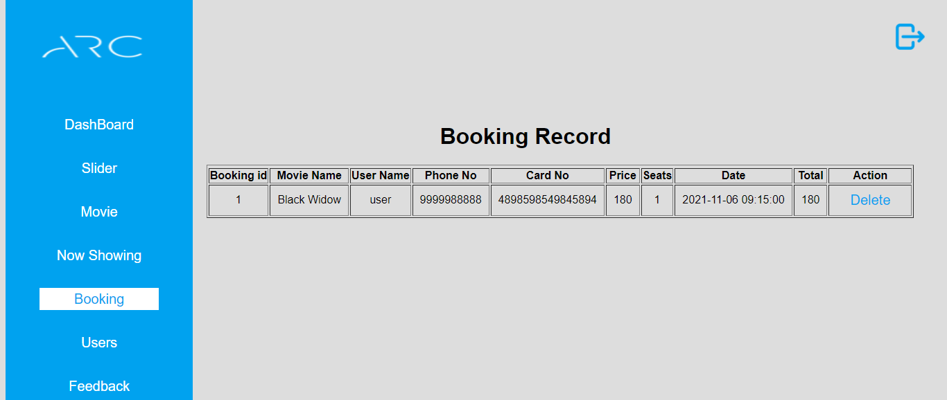

**Listusers.php**

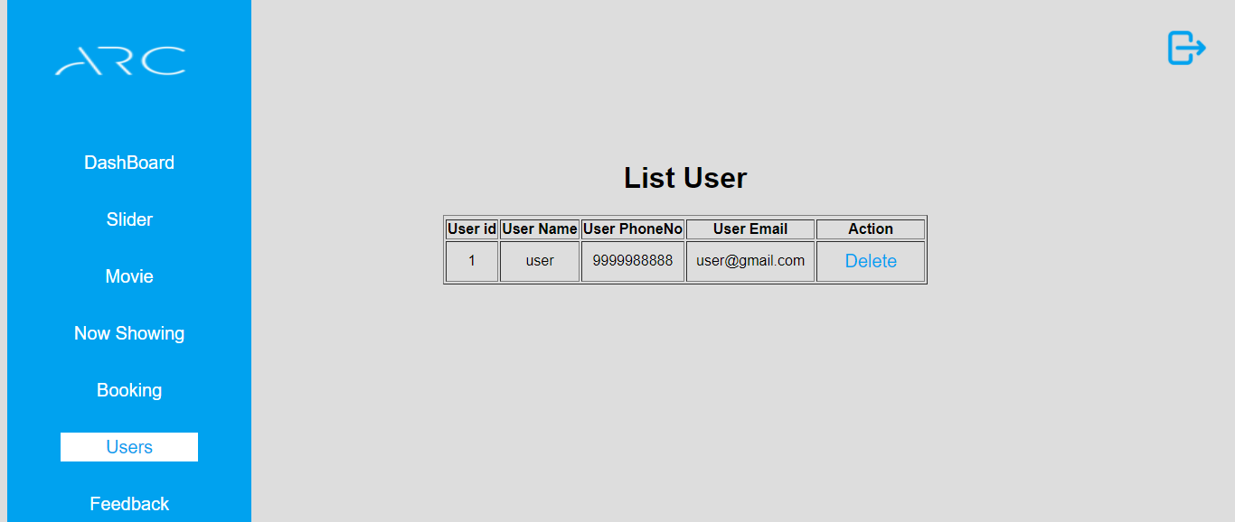

**Feedback.php**

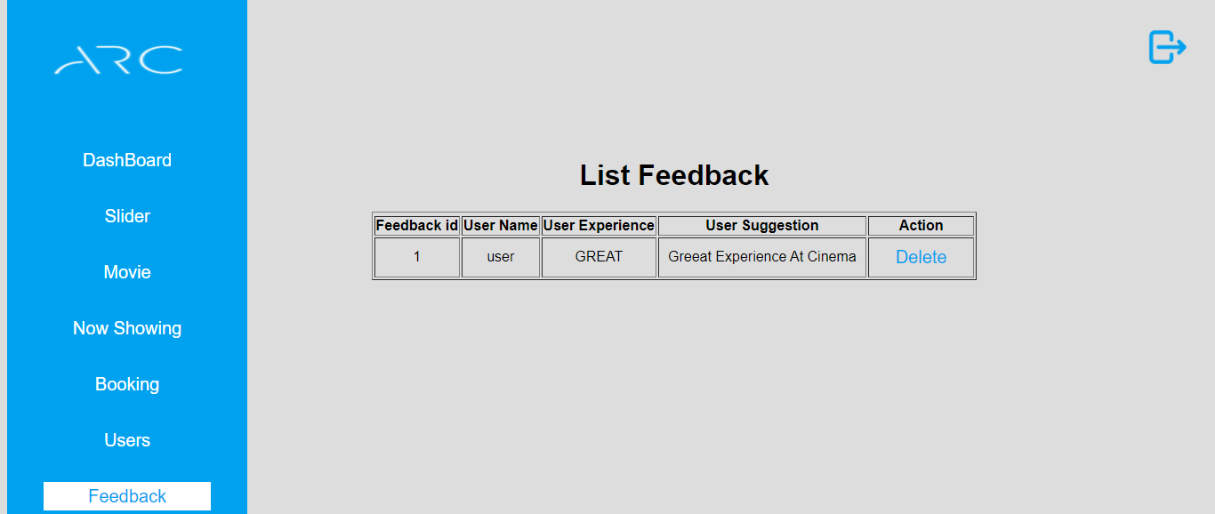

**Coding**

User Site

Index

<!DOCTYPE html>

<html>

<head>

<title>ARC</title>

<link rel="stylesheet" type="text/css" href="css/style.css">

</head>

<body>

<!-- Index Section Start -->

<?php include('header.php');?>

<!-- Index Section Start -->

<section class="banner" id="home">

<div class="slider-box">

<div id="slider">

<img src="img/s1.jpg">

<img src="img/s2.jpg">

<img src="img/s3.jpg">

</div>

</div>

<div class="indicators">

<span id="btn1" class="active"></span>

<span id="btn2"></span>

<span id="btn3"></span>

</div>

</section>

<!--First Section Start -->

<section class="sec1" id="media">

<div class="info">

<div class="col50">

<h2 class="titleText">What Is Cinema ?</h2><br><br>

<p class="text">

Is it the same as a movie or film? Does it include digital video, broadcast content, streaming media? Is it a highbrow term reserved only for European and art house feature films? Or is it a catch-all for any time a series of still images run together to produce the illusion of movement, whether in a multi-plex theater or the 5-inch screen of a smart phone?<br><br>

Technically, the word itself derives from the ancient Greek, kinema, meaning movement. Historically, it’s a shortened version of the French cinematographe, an invention of two brothers, Auguste and Louis Lumiere, that combined kinema with another Greek root, graphien, meaning to write or record.<br><br>

The “recording of movement” seems as good a place as any to begin an exploration of the moving image. And cinema seems broad (or vague) enough to capture the essence of the form, whether we use it specifically in reference to that art house film, or to refer to the more commonplace production and consumption of movies, TV, streaming series, videos, interactive gaming, VR, AR or whatever new technology mediates our experience of the moving image. Because ultimately that’s what all of the above have in common: the moving image. Cinema, in that sense, stands at the intersection of art and technology like nothing else.As an art form it would not exist without the technology required to capture the moving image. But the mere ability to record a moving image would be meaningless without the art required to capture our imagination.

</p>

</div>

<div class="col50">

<div class="mediaimg">

<img src="img/s7.jpg">

</div>

</div>

</div>

<div class="info">

<div class="col50">

<div class="mediaimg">

<img src="img/s6.jpg">

</div>

</div>

<div class="col50">

<p class="text">But cinema is much more than the intersection of art and technology. It is also, and maybe more importantly, a powerful medium of communication. Like language itself, cinema is a surrounding and enveloping substance that carries with it what it means to be human in a specific time and place. That is to say, it mediates our experience of the world, helps us make sense of things, and in doing so, often helps shape the world itself. It’s why we often find ourselves confronted by some extraordinary event and find the only way to describe it is: “It was like a movie.”<br><br>

In fact, for more than a century, filmmakers and audiences have collaborated on a massive, ongoing, largely unconscious social experiment: the development of a cinematic language, the fundamental and increasingly complex rules for how cinema communicates meaning. There is a syntax, a grammar, to cinema that has developed over time. And these rules, as with any language, are iterative, that is, they form and evolve through repetition, both within and between each generation. As children we are socialized into ways of seeing through children’s programming, cartoons and YouTube videos. <br><br>

As adults we become more sophisticated in our understanding of the rules, able to innovate, re-combine, become creative with the language. And every generation or so, we are confronted with great leaps forward in technology that re-orient and often advance our understanding of how the language works. And therein lies the critical difference between cinematic language and every other means of communication. The innovations and complexity of modern written languages have taken more than 5,000 years to develop. Multiply that by at least 10 for spoken language.Cinematic language has taken just a little more than 100 years to come into its own.

</p>

</div>

</div>

</section>

<!--First Section End -->

<!-- Second Section Start -->

<section class="sec2">

<h2 class="title"><span>All Time Best</span><a href="movie.php">Show All ></a></h2>

<div class="small-container">

<div class="col-5">

<div class="img"><img src="poster/poster1.jpg"></div>

<div class="content">

<h4>300</h4>

<p>In 480 B.C. a state of war exists between Persia, led by King Xerxes (Rodrigo Santoro), and Greece. At the Battle of Thermopylae, Leonidas (Gerard Butler), king of the Greek city state of Sparta.</p>

</div>

</div>

<div class="col-5">

<div class="img"><img src="poster/poster2.jpg"></div>

<div class="content">

<h4>Hacked</h4>

<p>Sameera's boyfriend disappoints her on her birthday and she ends up sleeping with Vivek, her neighbour. However, when she rebuffs his love, Vivek hacks into everything and makes her life miserable.</p></div>

</div>

<div class="col-5">

<div class="img"><img src="poster/poster3.jpg"></div>

<div class="content">

<h4>Black widow</h4>

<p>At birth the Black Widow (aka Natasha Romanova) is given to the KGB, which grooms her to become its ultimate operative. </p></div>

</div>

<div class="col-5">

<div class="img"><img src="poster/poster4.jpg"></div>

<div class="content">

<h4>Superman:Man of steel</h4>

<p>With the imminent destruction of Krypton, their home planet, Jor-El (Russell Crowe) and his wife seek to preserve their race by sending their infant son to Earth. </p></div>

</div>

<div class="col-5">

<div class="img"><img src="poster/poster5.jpg"></div>

<div class="content">

<h4>Brave</h4>

<p>Merida (Kelly Macdonald), the impetuous but courageous daughter of Scottish King Fergus (Billy Connolly) and Queen Elinor (Emma Thompson), is a skilled archer who wants to carve out her own path in life.</p>

</div>

</div>

<div class="col-5">

<div class="img"><img src="poster/poster6.jpg"></div>

<div class="content">

<h4>Rocky</h4>

<p>Jake Sully (Sam Worthington), a paralyzed former Marine, becomes mobile again through one such Avatar and falls in love with a Na'vi woman. As a bond with her grows, he is drawn into a battle for the survival of her world.</p>

</div>

</div>

</div>

</section>

<!-- Second Section Ends -->

<!-- Footer Section Start -->

<?php include('footer.php');?>

<!-- Footer Section Ends -->

<script type="text/javascript">

var slider = document.getElementById("slider");

var btn1 = document.getElementById("btn1");

var btn2 = document.getElementById("btn2");

var btn3 = document.getElementById("btn3");

btn1.onclick = function(){

slider.style.transform = "translateX(0px)";

btn1.classList.add("active");

btn2.classList.remove("active");

btn3.classList.remove("active");

btn4.classList.remove("active");

}

btn2.onclick = function(){

slider.style.transform = "translateX(-100%)";

btn2.classList.add("active");

btn1.classList.remove("active");

btn3.classList.remove("active");

btn4.classList.remove("active");

}

btn3.onclick = function(){

slider.style.transform = "translateX(-200%)";

btn3.classList.add("active");

btn1.classList.remove("active");

btn2.classList.remove("active");

btn4.classList.remove("active");

}

btn4.onclick = function(){

slider.style.transform = "translateX(-300%)";

btn4.classList.add("active");

btn1.classList.remove("active");

btn2.classList.remove("active");

btn3.classList.remove("active");

}

function toggleMenu(){

const navigation = document.querySelector('.navigation');

navigation.classList.toggle('active');

}

</script>

</body>

</html>

Header

<header>

<a href="#" class="logo"><img src="img/logo.png"> </a>

<ul class="navigation">

<li><a href="index.php">HOME</a></li>

<li><a href="about.php">ABOUT</a></li>

<li><a href="movie.php">MOVIE</a></li>

<li><a href="contact.php">CONTACT</a></li>

<li><a href="nowshowing.php">NOW SHOWING</a></li>

<li><a href="feedback.php">FEEDBACK</a></li>

</ul>

<?php

session_start();

if (isset($_SESSION['un']))

{

?>

<div class="login"><a href="logout.php" onclick="return confirmLogout()">Logout</a></div>

<?php

}

else

{

?>

<div class="login"><a href="login.php" >Login</a></div>

<?php

}

?>

<script type="text/javascript">

function confirmLogout(){

return confirm("Are you sure you want to Logout from this Website?");

}

</script>

</header>

Footer

<footer>

<div id="contact" class="social">

<a href="#"><img class="img1" src="img/facebook.png"></a>

<a href="#"><img class="img2" src="img/instagram.png"></a>

<a href="#"><img class="img3" src="img/twitter.png"></a>

</div>

<div class="footer">

<p>COPYRIGHT © 2021 ARC || ALL RIGHTS RESERVED.</p>

</div>

</footer>

About

<!DOCTYPE html>

<html>

<head>

<title>About us</title>

<link rel="stylesheet" type="text/css" href="css/style.css">

</head>

<body>

<?php include('header.php');?>

<section class="about_sec1"></section>

<section class="about_sec2">

<div class="main">

<div class="title">

<h1 align="center">About</h1>

<h3 align="center">"India's Most Trusted <br> Cinema Display <br> Brand."</h3>

</div>

<div class="text">

<p>Arc (Ace Realm Carnival) is the market leader in terms of screen count in India. Since 1997, the brand has redefined the cinema industry and the way people watch movies in the country. The Company has, over the years, consistently added screens, both organically and inorganically.</p>

<p>We offer a diversified cinema viewing experience through our formats, including ‘ARC Director’s Cut’, ‘ARC LUXE’, ‘ARC IMAX’, ‘ARC Superplex’ and pursuant to our acquisition and amalgamation of SPI Cinemas, ‘Escape’, ‘Sathyam’ and ‘Palazzo’. The Company exhibits diversified content to serve different regional customer segments across India.</p>

<p>We have a diversified revenue stream and generate revenues primarily from box office and non-box office which primarily includes revenue from Sale of Food and Beverages, advertisement income, convenience fees, and income from movie production/ distribution among others.</p>

</div>

</div>

<?php include('footer.php');?>

</section>

</body>

</html>

Movie

<!DOCTYPE html>

<html>

<head>

<title>ARC</title>

<link rel="stylesheet" type="text/css" href="css/style.css">

</head>

<body>

<?php $title="main";?>

<?php include('header.php');?>

<section class="s_sec" id="gallery">

<div class="small-container">

<?php

include_once 'DBConfig.php';

$sql = " SELECT * FROM movie ";

$result = mysqli_query($con,$sql);

while ($row = mysqli_fetch_assoc($result)) {

?>

<div class="col-5">

<div class="img"><img src="poster/<?php echo($row['m_img']) ?>"></div>

<div class="content"><h4><?php echo($row['m_name']) ?></h4>

<p><?php echo($row['m_des']) ?></p>

</div>

</div>

<?php

}

?>

</div>

</section>

<?php include('footer.php');?>

</body>

</html>

Contact

<!DOCTYPE html>

<html>

<head>

<title>Contact US page</title>

<link rel="stylesheet" type="text/css" href="css/style.css">

</head>

<body class="contact">

<?php include('header.php');?>

<div class="content">

<h1 align="center">Address</h1>

<p align="center">ARC Theater,<br>30,Street no 14,near crystal mall,khodiyar colony,<br>Jamnagar,361001.</p>

</div>

<div class="content">

<h1 align="center">Contact Number</h1>

<p align="center">(0288)2478548</p>

</div>

<div class="content">

<h1 align="center">E-mail ID</h1>

<p align="center">ARC@gmail.com</p>

</div>

<div class="contact_footer">

<?php include('footer.php');?>

</div>

</body>

</html>

Now Showing

<!DOCTYPE html>

<html>

<head>

<title>booking</title>

<link rel="stylesheet" type="text/css" href="css/style.css">

</head>

<body class="booking">

<?php include('header.php');?>

<div class="movie">

<?php

include_once 'DBConfig.php';

$sql = " SELECT * FROM current_movie ";

$result = mysqli_query($con,$sql);

while ($row = mysqli_fetch_assoc($result)) {

?>

<a href="single.php?mid=<?php echo $row['m_id'] ?>"><img src="poster/<?php echo($row['m_img']) ?>"></a>

<?php

}

?>

</div>

<?php include('footer.php');?>

</body>

</html>

Single

<?php

session_start();

?>

<!DOCTYPE html>

<html>

<head>

<title>ARC</title>

<link rel="stylesheet" type="text/css" href="css/single.css">

</head>

<body>

<a href="nowshowing.php"><img src="img/close.png"></a>

<section>

<form action="checkout.php" method="POST">

<?php

include("DBConfig.php");

extract($_GET);

$sql = "select * from current_movie where m_id=$mid";

$result = mysqli_query($con,$sql);

while ($row = mysqli_fetch_assoc($result)) {

?>

<div class="content">

<img src="poster/<?php echo $row['m_img'];?>">

</div>

<div class="text">

<h1><br></h1>

<table align="center">

<tr>

<td><td><input type="hidden" name="m_id" value="<?php echo($row['m_id']); ?>" ></td></td>

<?php $_SESSION['m_id'] = $row['m_id'] ?>

</tr>

<tr>

<td><h2>Movie Name:</h2></td>

<td><p><?php echo row['m_name'];?></p></td>

</tr>

<tr>

<td><h2>Time:</h2></td>

<td><p><?php echo $row['date'];?></p></td>

</tr>

<tr>

<td><h2>Price:</h2></td>

<td><p>Rs. <?php echo $row['price'];?></p></td>

</tr>

<tr>

<td><h2>Description:</h2></td>

<td><p><?php echo $row['m_desc'];?></p></td>

</tr>

<tr>

<td><h2>Tickets Quantity:</h2></td>

<td align="center"><input type="text" name="seatBooking" required="" value="1"></td>

</tr>

<tr>

<td><h2>Available Seats:</h2></td>

<td><p><?php echo $row['seats'];?></p></td>

</tr>

</table>

<input class="bookbtn" type="submit" name="submit" value="Book Show">

<?php

}

?>

</form>

</div>

</section>

</body>

Checkout

<?php

session_start();

include_once 'DBConfig.php';

$sql = " select * from current_movie WHERE m_id= '" . $_SESSION['m_id'] . "' " ;

$result = mysqli_query($con,$sql);

$row = mysqli_fetch_assoc($result);

$_SESSION['seatBooking'] = $_POST['seatBooking'];

if(isset($_REQUEST['submit'])){

if (!isset($_SESSION['un'])) {

echo "<script>alert('You have to login first.');window.location.href='login.php'</script>";

}

elseif ($row['seats']==0) {

echo "<script>alert('Sorry all seats are booked!!');window.location.href='nowshowing.php'</script>";

}

elseif($row['seats']<$_SESSION['seatBooking']){

echo "<script>alert('insufficient seats!!');window.location.href='nowshowing.php'</script>";

}

}

?>

<!DOCTYPE html>

<html>

<head>

<title>Checkout page </title>

<link rel="stylesheet" type="text/css" href="css/checkout.css">

</head>

<body>

<table class="headtable" border="1" align="center">

<tr>

<td><p>Movie Name</p></td>

<td><p>Ticket Price</p></td>

<td><p>Ticket Quantity</p></td>

<td><p>Total</p></td>

</tr>

<?php

include("DBConfig.php");

extract($_POST);

$sql = "select * from current_movie where m_id='" . $_SESSION['m_id'] . "'";

$result = mysqli_query($con,$sql);

while ($row = mysqli_fetch_assoc($result)) {

?>

<tr class="body">

<td><p><?php echo $row['m_name'];?></p></td>

<td><p><?php echo $row['price'];?></p></td>

<td><p><?php echo $_SESSION['seatBooking'];?></p></td>

<td><p><?php echo ($_SESSION['seatBooking'] * $row['price']); ?></p></td>

</tr>

</table>

<form action="saveTicket.php" method="POST">

<table class="bodytable" align="center">

<tr align="center">

<td><p>Movie Name:</p></td>

<td><input type="text" name="movieName" value="<?php echo $row['m_name'];?>" autocomplete="off" readonly="readonly"></td>

</tr>

<tr align="center">

<td><p>Seat Booking:</p></td>

<td><input type="text" name="seatBooking" value="<?php echo $_SESSION['seatBooking'];?>" autocomplete="off" readonly="readonly"></td>

</tr>

<tr align="center">

<td><p>Price:</p></td>

<td><input type="text" name="moviePrice" value="<?php echo $row['price'];?>" autocomplete="off" readonly="readonly"></td>

</tr>

<tr align="center">

<td><p>Date and Time:</p></td>

<td><input type="text" name="date" value="<?php echo $row['date'];?>" autocomplete="off" readonly="readonly"></td>

</tr>

<tr align="center">

<td><p>Total:</td><td><input type="text" name="total" value="<?php echo ($_SESSION['seatBooking'] * $row['price']); ?>" autocomplete="off" readonly="readonly"></td>

</tr>

<tr align="center">

<td><p>Your Name:</p></td>

<td><input type="text" name="userName" required autocomplete="off"></td>

</tr>

<tr align="center">

<td><p>Phone No:</p></td>

<td><input type="text" name="phoNo" required autocomplete="off"></td>

</tr>

</table>

<table align="center">

<tr>

<th colspan="2"><h1>Enter Card Detail:</h1></th>

</tr>

<tr align="center">

<td><p>Card number:</p></td>

<td><input type="text" name="cardNo" required autocomplete="off" maxlength="16"></td>

</tr>

<tr align="center">

<td><p>Card Expiry Date:</p></td>

<td class="s">

<select>

<option>january</option>

<option>fabuary</option>

<option>march</option>

<option>april</option>

<option>may</option>

<option>june</option>

<option>july</option>

<option>august</option>

<option>september</option>

<option>octomber</option>

<option>november</option>

<option>December</option>

</select>

<select>

<option>21</option>

<option>22</option>

<option>23</option>

<option>24</option>

<option>25</option>

<option>26</option>

<option>27</option>

</select></td>

</tr>

<tr align="center">

<td><p>Cvv:</p></td>

<td><input type="text" name="cvvNo" required autocomplete="off" maxlength="3"></td>

</tr>

</table>

<div class="link">

<a href="single.php?mid=<?php echo $row['m_id'] ?>"><p><-Go Back</p></a>

<input class="btn" type="submit" name="submit" value="Continue Booking">

</div>

</form>

<?php

}

?>

</body>

</html>

Success

<!DOCTYPE html>

<html>

<head>

<title>Ticket Summary</title>

<link rel="stylesheet" type="text/css" href="css/checkout.css">

</head>

<body class="success">

<table class="headtable1" border="1" align="center">

<tr>

<th colspan="6"><h1>TICKET SUMMARY</h1></th>

</tr>

<tr>

<td><p>Id</p></td>

<td><p>Name</p></td>

<td><p>Movie Name</p></td>

<td><p>Ticket Price</p></td>

<td><p>Ticket Quantity</p></td>

<td><p>Total</p></td>

</tr>

<?php

session_start();

include_once 'DBConfig.php';

$sql = "select * from booking where bookId= '" . $_SESSION['bookId'] . "' " ;

$result = mysqli_query($con,$sql);

while ($row = mysqli_fetch_assoc($result)) {

?>

<tr class="body">

<td><p><?php echo $_SESSION['bookId'];?></p></td>

<td><p><?php echo $row['userName'];?></p></td>

<td><p><?php echo $row['movieName'];?></p></td>

<td><p><?php echo $row['moviePrice'];?></p></td>

<td><p><?php echo $row['seatBooking'];?></p></td>

<td><p><?php echo $row['total'];?></p></td>

</tr>

<?php

}

?>

</table>

</body>

</html>

Feedback

<!DOCTYPE html>

<html>

<head>

<title>FeedBack Form</title>

<link rel="stylesheet" type="text/css" href="css/style.css">

</head>

<body class="feedback">

<?php include('header.php');?>

<div class="center">

<form action="query.php" method="POST">

<h1><p>Send Your Feedback</p></h1>

<div class="txt">

Enter your name<br>

<input type="text" name="name" placeholder="Write Here..." required autocomplete="off">

</div>

<div class="txt">

What was your Experince!<br>

<input class="rb" type="radio" name="experince" required="" value="BAD">BAD

<input class="rb" type="radio" name="experince" required="" value="NICE">NICE

<input class="rb" type="radio" name="experince" required="" value="GREAT">GREAT

</div>

<div class="txt">

Do you have any suggestion for us?<br>

<textarea cols="40" rows="3" placeholder="Type Something..." name="suggestion" required></textarea>

</div>

<div class="btn">

<button type="submit" name="feedback">Submit</button>

<button type="reset">Reset</button>

</div>

</form>

</div>

<div class="feedback_footer">

<?php include('footer.php');?>

</div>

</body>

</html>

Login

<?php

session_start();

?>

<!DOCTYPE html>

<html>

<head>

<title>Login</title>

<link rel="stylesheet" type="text/css" href="css/login.css">

</head>

<body>

<a href="index.php"><img src="img/close.png"></a>

<div class="center">

<h1>Login</h1>

<form action="query.php" method="POST">

<div class="txt">

<input type="email" name="email" required placeholder="Enter Your Email" autocomplete="off" autofocus>

</div>

<div class="txt">

<input type="password" name="pass" required placeholder="Enter Your Password">

</div>

<div class="btn">

<input type="submit" name="login" value="Login">

<input type="reset" value="Reset">

</div>

<div class="signup">

Not a member?<a href="signup.php">Signup</a>

</div>

</form>

</div>

</body>

</html>

Signup

<!DOCTYPE html>

<html>

<head>

<title>Signup</title>

<link rel="stylesheet" type="text/css" href="css/signup.css">

<script language="javascript">

</script>

</head>

<body>

<a href="login.php"><img src="img/close.png"></a>

<div class="center">

<h1>Signup</h1>

<form action="query.php" method="POST">

<div class="txt">

<input type="text" name="name" value="" required placeholder="Enter Your Name" autocomplete="off" autofocus>

</div>

<div class="txt">

<input type="text" name="phno" value="" required placeholder="Enter Phone Number" autocomplete="off">

</div>

<div class="txt">

<input type="email" name="email" value="" required placeholder="Example@gmail.com" autocomplete="off">

</div>

<div class="txt">

<input type="password" name="pass" value="" required placeholder="Enter Password">

</div>

<div class="txt">

<input type="password" name="cpass" value="" required placeholder="Confirm Passwrod">

</div

<div class="btn">

<input type="submit" name="signup" value="Signup" onclick="chk(this.form)">

<input type="reset" value="Reset">

</div>

</form>

</div>

</body>

</html>

DBConfig

<?php

$con = mysqli_connect("localhost","root","","arc");

?>

Logout

<?php

session_start();

session_unset();

session_destroy();

header("location:index.php");

?>

Query

<?php

session_start();

include("DBConfig.php");

//REGISTER

if(isset ($_POST['signup']))

{

$name =mysqli_real_escape_string($con, $_POST['name']);

$email =mysqli_real_escape_string($con, $_POST['email']);

$phno =mysqli_real_escape_string($con, $_POST['phno']);

$pass =mysqli_real_escape_string($con, $_POST['pass']);

$cpass =mysqli_real_escape_string($con, $_POST['cpass']);

$sql = "select * from user where email='$email'";

$result = mysqli_query($con,$sql);

$row = mysqli_fetch_assoc($result);

if($row)

{

echo "<script>alert('Email Id is Alredy Taken. Try Another Email Id!');window.location.href='signup.php'</script>";

}

else

{

if(strlen($pass) >= 6)

{

if($pass==$cpass)

{

if(is_numeric($phno) && strlen($phno)==10)

{

$sql = "insert into user values(null, '$name', '$phno', '$email', '$pass')";

$result = mysqli_query($con,$sql);

echo "<script>alert('Congratulations !! you are register to my website');window.location.href='login.php'</script>";

}

else

{

echo "<script>alert('Phone Number Should be Numeric and must be 10');window.location.href='signup.php'</script>";

}

}

else

{

echo "<script>alert('password should be match');window.location.href='signup.php'</script>";

}

}

else

{

echo "<script>alert('password should be more than 6 character');window.location.href='signup.php'</script>";

}

}

}

// LOGIN

else if(isset ($_POST['login']))

{

$e =mysqli_real_escape_string($con, $_POST['email']);

$p =mysqli_real_escape_string($con, $_POST['pass']);

$sql = "select * from user where email='$e' and binary pass='$p'";

$result = mysqli_query($con,$sql);

$row = mysqli_fetch_assoc($result);

if($row){

$_SESSION['un'] = $row['name'];

$_SESSION['ue'] = $row['email'];

echo "<script>alert('welcome to our site');window.location.href='index.php' </script>";

}

else{

echo "<script>alert('Email or Password does not match.');window.location.href='login.php' </script>";

}

}

// ADMIN LOGIN

else if(isset ($_POST['adminLogin']))

{

$e =mysqli_real_escape_string($con, $_POST['email']);

$p =mysqli_real_escape_string($con, $_POST['pass']);

$sql = "select * from admin where a_email='$e' and binary a_pass='$p'";

$result = mysqli_query($con,$sql);

$row = mysqli_fetch_assoc($result);

if($row){

$_SESSION['aue'] = $row['a_email'];

echo "<script>alert('welcome');window.location.href='admin/index.php' </script>";

}

else{

echo "<script>alert('Email or Password does not match.');window.location.href='admin/alogin.php' </script>";

}

}

//ADMIN REGISTER

elseif (isset ($_POST['addAdmin'])) {

$e =mysqli_real_escape_string($con, $_POST['a_email']);

$p =mysqli_real_escape_string($con, $_POST['a_pass']);

$sql = "select * from admin where a_email='$e' and binary a_pass='$p'";

$result = mysqli_query($con,$sql);

$row = mysqli_fetch_assoc($result);

if($row)

{

echo "<script>alert('Email Id is Alredy Taken. Try Another Email Id!');window.location.href='admin/index.php'</script>";

}

else

{

$sql = "insert into admin values(null, '$e', '$p')";

$result = mysqli_query($con,$sql);

echo "<script>alert('Congratulations !! you created new admin for this webbsite.');window.location.href='admin/index.php'</script>";

}

}

//feedback insert into database

elseif (isset ($_POST['feedback'])) {

extract($_POST);

$sql = "INSERT INTO feedback (f_id, name, experince, suggestion) VALUES (NULL, '$name', '$experince', '$suggestion')";

$result = mysqli_query($con,$sql);

echo "<script>alert('Thanks for submit your feedback.');window.location.href='feedback.php'</script>";

}

?>

Save Ticket

<?php

session_start();

include("DBConfig.php");

$sql1 = " select * from current_movie WHERE m_id= '" . $_SESSION['m_id'] . "' " ;

$result = mysqli_query($con,$sql1);

$row = mysqli_fetch_assoc($result);

if(isset($_REQUEST['submit'])){

if(!$row['seats']==0 && $row['seats']>=$_SESSION['seatBooking']){

extract($_POST);

$sql = "INSERT INTO booking(bookId, movieName, userName, phoNo, cardNo, moviePrice, seatBooking, date, total) VALUES (NULL,'$movieName','$userName','$phoNo','$cardNo','$moviePrice','$seatBooking','$date','$total')";

$temp = (int)$row['seats'] - (int)$_SESSION['seatBooking'] ;

$sql2 = "UPDATE current_movie SET seats='$temp' WHERE m_id='" . $_SESSION['m_id'] . "' ";

mysqli_query($con,$sql2);

mysqli_query($con,$sql);

if(mysqli_errno($con)){

$_SESSION['err'] = "Opps... some error occurrerd ";

header("Location: checkout.php");

}

else{

$_SESSION['msg'] = "Ticket booked successfully";

$sql4 = "SELECT bookId FROM booking ORDER BY bookId DESC LIMIT 1;";

$result4 = mysqli_query($con,$sql4);

$row4 = mysqli_fetch_assoc($result4);

$_SESSION['bookId'] = $row4['bookId'];

header("Location: success.php");}

}

}

?>

Style.css

*

{

margin: 0;

padding: 0;

box-sizing: border-box;

font-family: 'Poppins', sans-serif;

scroll-behavior: smooth;

body

{

background: linear-gradient(to right,#2b2b2b 0%,#000 100%);

min-height: 1000px;

}

.tab

{

margin-left: 20px;

}

/*header section start*/

header

{

position: fixed;

top: 0;

left: 0;

width: 100%;

padding: 5px 30px;

height: 80px;

background: #181818;

z-index: 50;

display: flex;

justify-content: space-between;

align-items: center;

transition: 0.5s;

}

header .logo

{

text-decoration: none;

}

.logo img

{

height: 35px;

width: 150px;

}

header .navigation

{

position: relative;

display: flex;

margin-left: 175px;

}

header .navigation li

{

list-style: none;

margin-left: 40px;

}

header .navigation li a

{

text-decoration: none;

color: #fff;

font-family: times new roman;

font-size: 20px;

opacity: 0.5;

font-weight: 300;

display: inline-block;

padding: 5px;

border-radius: 30px;

margin-top: 2px;

transition: 0.5s;

}

header .navigation li a:hover

{

opacity: 1;

background-color: #00a2ef;

box-shadow: 0 0 10px #00a2ef;

}

.login a

{

text-decoration: none;

padding: 5px 10px;

color: #fff;

font-family: times new roman;

font-size: 20px;

transition: 0.5s ease;

}

.login a:hover

{

background-color: #00a2ef;

box-shadow: 0 0 5px #ddd,0 0 10px #ddd;

border-radius: 10%;

}

/*header section ends*/

/*banner section start*/

.banner .slider-box

{

width: 100%;

height: 100vh;

position: relative;

overflow: hidden;

}

#slider

{

width: 100%;

display: inline-flex;

display: block ruby;

height: 100vh;

transition: 0.7s;

}

#slider img

{

width: 100%;

background-size: 80% 100%;

}

.indicators

{

position: absolute;

left: 50%;

bottom: 10px;

transform: translateX(-50%);

}

.indicators span

{

display: inline-block;

width: 150px;

box-shadow: 0 0 5px #555;

margin: 5px;

height: 10px;

background: rgba(18,18,18,0.5);

cursor: pointer;

transition: 0.5s;

}

.indicators span:hover

{

background: rgba(255,255,255,0.5);

}

.active

{

background: #fff !important;

box-shadow: 0 0 5px #fff;

}

/*banner section ends

/*First Section Start*/

.sec1

{

background-image: linear-gradient(rgba(20,20,20,0.3), rgba(20,20,20,0.3)),url('../img/s8.jpg');

background-size: cover;

}

.info

{

padding: 50px;

position: relative;

width: 100%;

display: flex;

justify-content: space-between;

}

.info .col50

{

position: relative;

width: 48%;

}

.titleText

{

color: #fff;

font-size: 2em;

font-weight: 300;

margin-bottom: 5px;

}

.col50 .text

{

color: #fff;

font-size: 17px;

}

.info .col50 .mediaimg

{

position: : relative;

width: 100%;

min-height: 300px;

}

.info .col50 .mediaimg img

{

position: absolute;

top: 0;

left: 0;

width: 100%;

height: 500px;

object-fit: cover;

}

/*First Section Ends*/

/*Second section start*/

.title

{

text-align: left;

margin-top: 40px;

margin-left: 80px;

position: relative;

font-size: 30px;

line-height: 60px;

color: #555;

display: flex;

justify-content: space-between;

}

.title a

{

font-size: 20px;

color: #999;

margin-right: 50px;

text-decoration: none;

transition: 0.5s;

}

.title a:hover

{

letter-spacing: 2px;

color: #fff;

}

.title span

{

transition: 0.5s;

}

.title span:hover

{

color: #fff;

}

.small-container

{

max-width: 1150px;

margin-left: 100px;

padding-top: 20px;

display: flex;

align-items: center;

flex-wrap: wrap;

justify-content: space-between;

}

.col-5

{

flex-basis: 5%;

min-width: 350px;

height: 250px;

border-radius: 20px;

margin-bottom: 30px;

transition: 0.5s;

overflow: hidden;

}

.col-5:hover

{

box-shadow: 0 0 10px #fff,0 0 15px #00acee,0 0 25px #00a2ef;

}

.col-5 a

{

text-decoration: none;

}

.img

{

overflow: hidden;

}

.col-5 img

{

width: 100%;

height: 250px;

opacity: 0.9;

transition: 0.3s ease-in;

}

.col-5 img:hover

{

filter: blur(2.5px);

}

.content .save

{

position: absolute;

float: right;

transform: translate(290px,-40px);

pointer-events: auto;

}

.content .save img

{

height: 25px;

width: 25px;

filter: invert(0.5);

transition: 0.5s;

}

.content .save img:hover

{

filter: invert(1);

}

.col-5 .content

{

transform: translateY(100px);

padding-left: 5px;

z-index: 500;

opacity: 0;

color: #fff;

text-shadow: 2px 2px 5px black;

margin: 10px;

pointer-events: none;

transition: 0.5s;

}

.col-5 .content h4

{

font-size: 30px;

}

.col-5 p

{

color: #fff;

text-transform: uppercase;

text-decoration: none

opacity: 0;

}

.col-5:hover .content

{

transform: translateY(-200px);

opacity: 1;

}

/*Second Section End*/

/*Footer Section Start*/

footer

{

width: 100%;

height: auto;

margin: auto;

background-color: #333;

}

footer .social

{

display: flex;

justify-content: center;

align-items: center;

border-radius: 100%;

}

footer .social a

{

margin: 35px;

color: #aaa;

text-shadow: 0 0 5px #000;

}

footer .social img

{

height: 55px;

width: 55px;

transition: 0.5s;

}

.footer p

{

font-size: 20px;

color: #fff;

display: flex;

padding-bottom: 20px;

justify-content: center;

}

/*Footer Section Ends*/

/*About page*/

.about_sec1

{

background-image: url(../img/s9.jpg);

background-size: cover;

min-height: 100vh;

background-attachment: fixed;

}

.about_sec2

{

height: 600px;

}

.about_sec2 .main

{

padding: 0 100px;

}

.about_sec2 .title

{

color: #fff;

display: block;

}

.about_sec2 .title h1

{

padding: 40px;

font-size: 40px;

text-transform: uppercase;

}

.about_sec2 .title h3

{

word-spacing: 5px;

font-size: 40px;

font-family: times new roman;

}

.about_sec2 img

{

height: 500px;

width: 100%;

}

.about_sec2 .text

{

display: flex;

color: #fff;

margin: 60px 0;

}

.about_sec2 .text p

{

padding: 0 20px;

}

.col-6

{

max-width: 1150px;

margin-left: -25px;

padding: 50px 0px;

display: flex;

align-items: center;

}

.col-6 .review

{

margin: 25px;

min-width: 250px;

height: 250px;

background: rgba(255,255,255,0.1);

color: #fff;

box-shadow: 5px 10px 5px rgba(0,0,0,0.5);

text-shadow: 2px 2px 2px #000;

overflow: hidden;

transition: 0.2s ease-in;

}

.col-6 img

{

margin-top: 20px;

margin-left: 30px;

width: 200px;

height: 200px;

transition: 0.5s;

}

.col-6 p

{

position: absolute;

opacity: 0;

font-size: 25px;

pointer-events: none;

}

.col-6 .review:hover

{

transform: translateY(-5px);

box-shadow: 10px 20px 5px rgba(0,0,0,0.5);

background: rgba(255,255,255,0.2);

}

.col-6 .review:hover img

{

margin-top: 15px;

margin-left: 75px;

width: 100px;

height: 100px;

}

.col-6 .review:hover p

{

opacity: 1;

transform: translate(40px,0px);

}

/*s_movie section style*/

.s_sec .small-container

{

padding-top: 100px;

}

.s_sec .small-container .col-5

{

flex-basis: 1%;

}

/*Contact Us page*/

.contact

{

min-height: 50px;

margin-top: 120px;

}

.contact .content

{

color: #fff;

margin-top: 50px;

}

.contact .content h1

{

margin-bottom: 30px;

text-decoration: underline;

}

.contact .content p

{

font-size: 20px;

letter-spacing: 3px;

}

.contact_footer

{

margin-top: 60px;

}

/*Booking Page*/

.booking

{

min-height: 500px;

background-image: linear-gradient(rgba(0,0,0,0.7), rgba(0,0,0,0.7)),url('../img/s10.jpg');

background-size: 100% 100%;

}

.movie

{

display: flex;

justify-content: space-around;

margin: 130px 0px 80px 0px;

}

.movie img

{

margin: 40px;

height: 400px;

width: 350px;

border: 2px solid white;

transition: 0.5s;

}

.movie img:hover

{

transform: scale(1.1);

}

/*---------------------*/

/*Feedback Page*/

.feedback

{

background-image: linear-gradient(rgba(0,0,0,0.1), rgba(0,0,0,0.7)),url('../img/s8.jpg');

background-size: 100% 100%;

min-height: 50px;

}

.center

{

color: #fff;

position: absolute;

top: 50%;

left: 50%;

font-size: 18px;

transform: translate(-50%, -43%);

background: rgba(25,25,25,0.6);

border-radius: 20px;

border: 1px solid rgba(255,255,255,0.4);

}

.center h1

{

padding: 20px 80px 20px 50px;

border-bottom: 2px solid silver;

color: #fff;

}

.center .txt

{

position: relative;

border-bottom: 2px solid #adadad;

margin: 20px 20px;

}

.txt input

{

width: 100%;

height: 40px;

padding: 10px;

font-size: 20px;

background: none;

border: none;

color: #fff;

}

.txt input:focus

{

outline: 2px solid #00a2ef;

}

.txt .rb

{

width: 20px;

height: 20px;

margin: 10px 10px 10px 30px;

}

.txt .rb:focus

{

outline: none;

}

.txt textarea

{

margin-top: 10px;

font-size: 20px;

padding: 10px;

background: none;

border: none;

color: #fff;

}

.txt textarea:focus

{

outline: 2px solid #00a2ef;

}

.center .btn

{

padding: 0px 40px 10px;

}

.btn button

{

background: #00a2ef;

color: #fff;

margin: 5px 20px;

padding: 10px 50px;

border: none;

font-size: 18px;

font-weight: bold;

border-radius: 20px;

}

.feedback_footer

{

margin-top: 660px;

}

Single.css

body

{

background-image: linear-gradient(to right,rgba(0,0,0,0.9), rgba(25,25,25,0.2), rgba(0,0,0,0.9)),url('../img/s4.jpg');

background-size: 100% 70%;

background-repeat: no-repeat;

background-color: #181818;

height: 100vh;

}

a

{

float: right;

padding: 20px;

}

.content

{

min-width: 350px;

height: 90vh;

width: 100px;

padding-top: 120px;

margin-left: 50px;

}

.content img

{

width: 50%;

height: 200px;

padding-top: 90px;

margin-left: 50px;

transform: scale(2);

}

table

{

width: 80%;

}

.text

{

position: relative;

transform: translateY(-150px);

color: #fff;

padding-left: 50px;

}

.text h1

{

font-size: 50px;

padding-left: 40px;

}

.text h2

{

margin: 20px;

margin-right: 50px;

}

.text p

{

font-size: 20px;

margin: 20px;

}

table input

{

width: 95%;

height: 30px;

font-size: 18px;

border: none;

}

table input:focus

{

outline: 2px solid #00a2ef;

}

input[type=submit]

{

background: #00a2ef;

color: #fff;

border: none;

font-size: 25px;

padding: 10px 40px;

font-weight: bold;

margin-top: 40px;

margin-left: 40%;

transition: 0.5s;

}

input[type=submit]:hover

{

background: #fff;

color: #00a2ef;

}

Checkout.css

body

{

background-image: url(../img/s11.jpg);

background-size: 100% 100%;

color: #fff;

}

.success

{

background-image: url(../img/s11.jpg);

background-size:100%;

}

.headtable

{

margin-top: 100px;

}

.headtable1

{

margin-top: 250px;

}

.bodytable

{

margin-top: 50px;

}

h1

{

text-shadow: 2px 2px black;

}

p

{

margin: 10px;

font-size: 25px;

text-shadow: 2px 2px black;

}

input[type="text"]

{

width: 100%;

height: 30px;

font-size: 22px;

}

input[type="text"]:focus

{

outline: 2px solid #00a2ef;

}

.s

{

display: flex;

}

.s select

{

width: 50%;

height: 35px;

font-size: 20px;

}

.link

{

margin-top: 25px;

display: flex;

margin-left: 500px;

}

.link .btn

{

background: none;

border: none;

color: #00a2ef;

font-size: 25px;

}

.link .btn:hover

{

text-decoration: underline;

}

a

{

color: #00a2ef;

text-decoration: none;

}

a:hover

{ text-decoration: underline;

}

Admin site:

Alogin

<?php

session_start();

?>

<!DOCTYPE html>

<html>

<head>

<title>Login</title>

<link rel="stylesheet" type="text/css" href="../css/login.css">

</head>

<body>

<a href="../index.php"><img src="../img/close.png"></a>

<div class="center">

<h1>Admin Login</h1>

<form action="../query.php" method="POST">

<div class="txt">

<input type="email" name="email" required placeholder="Enter Your Email-Id" autocomplete="off" autofocus>

</div>

<div class="txt">

<input type="password" name="pass" required placeholder="Enter Your Password">

</div>

<div class="signup">

</div>

<div class="btn">

<div class="extraspace">

<input type="submit" name="adminLogin" value="Login">

<input type="reset" value="Reset">

</div>

</div>

</form>

</div>

</body>

Index

<?php

include('sidebar.php');

?>

<form action="../query.php" method="POST">

<div class="table" id="dashboard">

<table align="center">

<tr>

<h1 align="center"> New Admin User <h1>

</tr>

<tr>

<td>User Email :</td>

<td><input type="text" name="a_email" required autocomplete="off"></td>

</tr>

<tr>

<td>Password :</td>

<td><input type="password" name="a_pass" required autocomplete="off"></td>

</tr>

<tr>

<td colspan="2" align="center"><input class="btn" type="submit" name="addAdmin" value="Add New Admin">

</tr>

</table>

</div>

</form>

Listslider

<?php include('sidebar.php'); ?>

<div class="add_movie" align="center">

<form>

<table class="listtable" border="1" width="900">

<tr>

<h1 align="center">Slider</h1>

<?php

if(isset($_SESSION['err'])){

?>

<span style="color: red"><?php echo($_SESSION['err']); ?></span>

<?php

unset($_SESSION['err']);

}

else if(isset($_SESSION['msg'])){

?>

<span style="color: green"><?php echo($_SESSION['msg']); ?></span>

<?php

unset($_SESSION['msg']);

}

?>

</tr>

<tr>

<th>Slider id</th>

<th>Slider Image</th>

<th>Action</th>

</tr>

<?php

include_once '../DBConfig.php';

$sql = "select * from slider";

$result = mysqli_query($con,$sql);

while($row = mysqli_fetch_assoc($result)){

?>

<tr>

<td align="center"><?php echo($row['s_id']); ?></td>

<td align="center"><img src='../img/<?php echo($row['s_img']) ?>' width=100px height=100px></td>

<td align="center"><a href="editslider.php?s_id=<?php echo($row['s_id']); ?>" ><font color="#00a2ef">Edit</font></a> </td>

</tr>

<?php

}

?>

</table>

</form>

</div>

List Movie

<?php include('sidebar.php'); ?>

<div class="add_movie" align="center">

<form>

<table class="listtable" border="1" width="900">

<tr>

<h1 align="center">List Movie</h1>

<a href="addEditMovie.php" class="btn btn-success" style="float: center;">Add Movie</a>

<?php

if(isset($_SESSION['err'])){

?>

<span style="color: red"><?php echo($_SESSION['err']); ?></span>

<?php

unset($_SESSION['err']);

}

else if(isset($_SESSION['msg'])){

?>

<span style="color: green"><?php echo($_SESSION['msg']); ?></span>

<?php

unset($_SESSION['msg']);

}

?>

</tr>

<tr>

<th>Movie id</th>

<th>Movie Name</th>

<th>Description</th>

<th>Image</th>

<th colspan="2">Action</th>

</tr>

<?php

include_once '../DBConfig.php';

$sql = "select * from movie";

$result = mysqli_query($con,$sql);

while($row = mysqli_fetch_assoc($result)){

?>

<tr>

<td align="center"><?php echo($row['m_id']); ?></td>

<td align="center"><?php echo($row['m_name']); ?></td>

<td align="center"><?php echo($row['m_des']); ?></td>

<td align="center"><img src='../poster/<?php echo($row['m_img']) ?>' width=100px height=100px></td>

<td align="center"><a href="addEditMovie.php?id=<?php echo($row['m_id']); ?>" ><font color="#00a2ef">Edit</font></a> </td>

<td align="center"><a href="deleteQuery.php?movieId=<?php echo($row['m_id']); ?>" ><font color="#00a2ef"> Delete</font></a> </td>

</tr>

<?php

}

?>

</table>

</form>

</div>

Add Edit Movie

<?php

include('sidebar.php');

if (isset($_GET['id'])) {

include_once '../DBConfig.php';

extract($_GET);

$sql = "select * from movie where m_id=$id";

$result = mysqli_query($con,$sql);

$row = mysqli_fetch_assoc($result);

if(!$row){

$_SESSION['err'] = "No record found to edit";

header("Location: listMovie.php");

}

}

?>

<div class="add_movie" align="center">

<form action="con_addEditMovie.php" enctype="multipart/form-data" method="POST">

<table>

<tr>

<h1 align="center">Add Movie</h1>

</tr>

<tr>

<?php

if(isset($_GET['id'])){

?>

<td>

<input type="hidden" name="m_id" value="<?php echo($row['m_id']); ?>" >

</td>

<?php

}

?>

</tr>

<tr align="center">

<td>Movie Name:</td><td><input type="text" name="m_name" required value="<?php if(isset($_GET['id'])){echo($row['m_name']);} ?>" autocomplete="off"><br></td>

</tr>

<tr align="center">

<td>Description:</td><td><textarea name="m_des" required><?php if(isset($_GET['id'])){echo($row['m_des']);} ?></textarea><br></td>

</tr>

<tr align="center">

<td>Movie Poster:</td><td><input type="file" name="m_img" required></td>

</tr>

</table>

<input class="btn" type="submit" name="" value="SUBMIT">

</form>

</div>

List cmovie

<?php include('sidebar.php'); ?>

<div class="add_movie" align="center">

<form>

<table class="listtable" id="tablespace" border="1" width="1000">

<tr>

<h1 align="center">Now Showing</h1>

<a href="addEditcMovie.php" class="btn btn-success" style="float: center;">Add Current Movie</a>

<!-- to print error msg -->

<?php

if(isset($_SESSION['err'])){

?>

<span style="color: red"><?php echo($_SESSION['err']); ?></span>

<?php

unset($_SESSION['err']);

}

else if(isset($_SESSION['msg'])){

?>

<span style="color: green"><?php echo($_SESSION['msg']); ?></span>

<?php

unset($_SESSION['msg']);

}

?>

<!-- end print error msg -->

</tr>

<tr>

<th>Movie id</th>

<th>Movie Name</th>

<th>Description</th>

<th>Seats</th>

<th>Price</th>

<th>Image</th>

<th colspan="2">Action</th>

</tr>

<?php

include_once '../DBConfig.php';

$sql = "select * from current_movie";

$result = mysqli_query($con,$sql);

while($row = mysqli_fetch_assoc($result)){

?>

<tr>

<td align="center"><?php echo($row['m_id']); ?></td>

<td align="center"><?php echo($row['m_name']); ?></td>

<td align="center"><?php echo($row['m_desc']); ?></td>

<td align="center"><?php echo($row['seats']); ?></td>

<td align="center"><?php echo($row['price']); ?></td>

<td align="center"><img src='../poster/<?php echo($row['m_img']) ?>' width=100px height=100px></td>

<td align="center"><a href="addEditcMovie.php?id=<?php echo($row['m_id']); ?>" ><font color="#00a2ef">Edit</font></a> </td>

<td align="center"><a href="deleteQuery.php?cmovieId=<?php echo($row['m_id']); ?>" ><font color="#00a2ef"> Delete</font></a> </td>

</tr>

<?php

}

?>

</table>

</form>

</div>

Add Edit cmovie

<?php

include('sidebar.php');

if (isset($_GET['id'])) {

include_once '../DBConfig.php';

extract($_GET);

$sql = "select * from current_movie where m_id=$id";

$result = mysqli_query($con,$sql);

$row = mysqli_fetch_assoc($result);

if(!$row){

$_SESSION['err'] = "No record found to edit";

header("Location: listcMovie.php");

}

}

?>

<div class="add_movie" align="center">

<form action="con_addEditcMovie.php" enctype="multipart/form-data" method="POST">

<table>

<tr>

<h1 align="center">Add Current Movie</h1>

</tr>

<tr>

<?php

if(isset($_GET['id'])){

?>

<td>

<input type="hidden" name="m_id" value="<?php echo($row['m_id']); ?>" >

</td>

<?php

}

?>

</tr>

<tr align="center">

<td>Movie Name:</td><td><input type="text" name="m_name" required value="<?php if(isset($_GET['id'])){echo($row['m_name']);} ?>" autocomplete="off"><br></td>

</tr>

<tr align="center">

<td>Description:</td><td><textarea name="m_desc" required><?php if(isset($_GET['id'])){echo($row['m_desc']);} ?></textarea><br></td>

</tr>

<tr align="center">

<td>Seats:</td><td><input type="text" name="seats" required value="<?php if(isset($_GET['id'])){echo($row['seats']);} ?>" autocomplete="off"><br></td>

</tr>

<tr align="center">

<td>Price:</td><td><input type="text" name="price" required value="<?php if(isset($_GET['id'])){echo($row['price']);} ?>" autocomplete="off"><br></td>

</tr>

<tr align="center">

<td>Movie Poster:</td><td><input type="file" name="m_img" required></td>

</tr>

<tr align="center">

<td>Date:</td><td><input type="datetime-local" name="date" required></td>

</tr>

</table>

<input class="btn" type="submit" name="" value="SUBMIT">

</form>

</div>

List Booking

<?php

include('sidebar.php');

?>

<div class="add_movie" align="center">

<form>

<table border="1" id="tablespace">

<tr>

<h1 align="center">Booking Record</h1>

<!-- to print error msg -->

<?php

if(isset($_SESSION['err'])){

?>

<span style="color: red"><?php echo($_SESSION['err']); ?></span>

<?php

unset($_SESSION['err']);

}

else if(isset($_SESSION['msg'])){

?>

<span style="color: green"><?php echo($_SESSION['msg']); ?></span>

<?php

unset($_SESSION['msg']);

}

?>

<!-- end print error msg -->

</tr>

<tr>

<th>Booking id</th>

<th>Movie Name</th>

<th>User Name</th>

<th>Phone No</th>

<th>Card No</th>

<th>Price</th>

<th>Seats</th>

<th>Date</th>

<th>Total</th>

<th>Action</th>

</tr>

<?php

include_once '../DBConfig.php';

$sql = "select * from booking";

$result = mysqli_query($con,$sql);

while($row = mysqli_fetch_assoc($result)){

?>

<tr>

<td align="center"><?php echo($row['bookId']); ?></td>

<td align="center"><?php echo($row['movieName']); ?></td>

<td align="center"><?php echo($row['userName']); ?></td

<td align="center"><?php echo($row['phoNo']); ?></td>

<td align="center"><?php echo($row['cardNo']); ?></td>

<td align="center"><?php echo($row['moviePrice']); ?></td>

<td align="center"><?php echo($row['seatBooking']); ?></td>

<td align="center"><?php echo($row['date']); ?></td>

<td align="center"><?php echo($row['total']); ?></td>

<td align="center"><a href="deleteQuery.php?bookId=<?php echo($row['bookId']); ?>" > <font color="#00a2ef">Delete </font></a> </td>

</tr>

<?php

}

?>

</table>

</form>

</div>

List User

<?php

include('sidebar.php');

?>

<div class="add_movie" align="center">

<form>

<table border="1">

<tr>

<h1 align="center">List User</h1>

<!-- to print error msg -->

<?php

if(isset($_SESSION['err'])){

?>

<span style="color: red"><?php echo($_SESSION['err']); ?></span>

<?php

unset($_SESSION['err']);

}

else if(isset($_SESSION['msg'])){

?>

<span style="color: green"><?php echo($_SESSION['msg']); ?></span>

<?php

unset($_SESSION['msg']);

}

?>

<!-- end print error msg -->

</tr>

<tr>

<th>User id</th>

<th>User Name</th>

<th>User PhoneNo</th>

<th>User Email</th>

<th>Action</th>

</tr>

<?php

include_once '../DBConfig.php';

$sql = "select * from user";

$result = mysqli_query($con,$sql);

while($row = mysqli_fetch_assoc($result)){

?>

<tr>

<td align="center"><?php echo($row['uid']); ?></td>

<td align="center"><?php echo($row['name']); ?></td>

<td align="center"><?php echo($row['phno']); ?></td>

<td align="center"><?php echo($row['email']); ?></td>

<td align="center"><a href="deleteQuery.php?userId=<?php echo($row['uid']); ?>" > <font color="#00a2ef">Delete </font></a> </td>

</tr>

<?php

}

?>

</table>

</form>

</div>

Feedback

<?php

include('sidebar.php');

?>

<div class="add_movie" align="center">

<form>

<table border="1">

<tr>

<h1 align="center">List Feedback</h1>

<!-- to print error msg -->

<?php

if(isset($_SESSION['err'])){

?>

<span style="color: red"><?php echo($_SESSION['err']); ?></span>

<?php

unset($_SESSION['err']);

}

else if(isset($_SESSION['msg'])){

?>

<span style="color: green"><?php echo($_SESSION['msg']); ?></span>

<?php

unset($_SESSION['msg']);

}

?>

<!-- end print error msg -->

</tr>

<tr>

<th>Feedback id</th>

<th>User Name</th>

<th>User Experience</th>

<th>User Suggestion</th>

<th>Action</th>

</tr>

<?php

include_once '../DBConfig.php';

$sql = "select * from feedback";

$result = mysqli_query($con,$sql);

while($row = mysqli_fetch_assoc($result)){

?>

<tr>

<td align="center"><?php echo($row['f_id']); ?></td>

<td align="center"><?php echo($row['name']); ?></td>

<td align="center"><?php echo($row['experince']); ?></td

<td align="center"><?php echo($row['suggestion']); ?></td>

<td align="center"><a href="deleteQuery.php?feedbackId=<?php echo($row['f_id']); ?>" ><font color="#00a2ef">Delete </font></a> </td>

</tr>

<?php

}

?>

</table>

</form>

</div>

Con_AddEditcmovie

<?php

session_start();

include_once '../DBConfig.php';

extract($_POST);

$m_img = $_FILES['m_img']['name'];

if(isset($m_id))

{

if (!empty($m_img))

{

$sql = "UPDATE current_movie SET m_name = '$m_name', m_desc = '$m_desc', seats = '$seats', price = '$price', m_img = '$m_img', date = '$date' WHERE m_id = $m_id" ;

}

else

{

$sql = "UPDATE current_movie SET m_name = '$m_name', m_desc = '$m_desc', seats = '$seats', price = '$price', m_img = '$m_img', date = '$date' WHERE m_id = $m_id" ;

}

}

else

{

$sql = "INSERT INTO current_movie (m_id, m_name, m_desc, seats, price, m_img, date) VALUES (NULL, '$m_name', '$m_desc', '$seats', '$price', '$m_img', '$date' )";

}

mysqli_query($con,$sql);

if(mysqli_errno($con))

{

if(isset($m_id))

{

$_SESSION['err'] = "Opps... some error occurrerd when Editing the Movie";

header("Location: listcMovie.php");

}

else

{

$_SESSION['err'] = "Opps... some error occurrerd when adding the Movie";

header("Location: listcMovie.php");

}

}

else{

if(isset($m_id))

{

move_uploaded_file($_FILES['m_img']['tmp_name'], "../poster/$m_img");

$_SESSION['msg'] = "Movie Edited successfully";

header("Location: listcMovie.php");

}

else

{

move_uploaded_file($_FILES['m_img']['tmp_name'], "../poster/$m_img");

$_SESSION['msg'] = "Movie added successfully";

header("Location: listcMovie.php");

}

}

?>

Con_addeditmovie

<?php

session_start();

include_once '../DBConfig.php';

extract($_POST);

$m_img = $_FILES['m_img']['name'];

if(isset($m_id))

{

if (!empty($m_img))

{

$sql = "UPDATE movie SET m_name = '$m_name', m_des = '$m_des', m_img = '$m_img' WHERE m_id = $m_id";

}

else

{

$sql = "UPDATE movie SET m_name = '$m_name', m_des = '$m_des' WHERE m_id = $m_id";

}

}

else

{

$sql = "INSERT INTO movie (m_id, m_name, m_des, m_img) VALUES (NULL, '$m_name', '$m_des', '$m_img')";

}

mysqli_query($con,$sql);

if(mysqli_errno($con))

{

if(isset($m_id))

{

$_SESSION['err'] = "Opps... some error occurrerd when Editing the Movie";

header("Location: listMovie.php");

}

else

{

$_SESSION['err'] = "Opps... some error occurrerd when adding the Movie";

header("Location: listMovie.php");

}

}

else{

if(isset($m_id))

{

move_uploaded_file($_FILES['m_img']['tmp_name'], "../poster/$m_img");

$_SESSION['msg'] = "Movie Edited successfully";

header("Location: listMovie.php");

}

else

{

move_uploaded_file($_FILES['m_img']['tmp_name'], "../poster/$m_img");

$_SESSION['msg'] = "Movie added successfully";

header("Location: listMovie.php");

}

}

?>

Con_editslider

<?php

session_start();

include_once '../DBConfig.php';

extract($_POST);

$s_img = $_FILES['s_img']['name'];

if(isset($s_id))

{

$sql = "UPDATE slider SET s_img='$s_img' WHERE s_id=$s_id";

}

mysqli_query($con,$sql);

if(mysqli_errno($con))

{

$_SESSION['err'] = "Opps... some error occurrerd when Editing the slider";

header("Location: listslider.php");

}

else{

move_uploaded_file($_FILES['s_img']['tmp_name'], "../img/$s_img");

$_SESSION['msg'] = "slider Edited successfully";

header("Location: listslider.php");

}

?>

DeleteQuery

<?php

session_start();

include '../DBConfig.php';

//delete movie

if(isset($_GET['movieId'])){

extract($_GET);

$sql = "DELETE FROM movie WHERE m_id = $movieId";

mysqli_query($con,$sql);

if(mysqli_errno($con)){

$_SESSION['err'] = "Opps... some error occurrerd when deleting the Movie";

header("Location: listMovie.php");

}

else{

$_SESSION['msg'] = "Movie deleted successfully";

header("Location: listMovie.php");

}

}

//delete current movie

if(isset($_GET['cmovieId'])){

extract($_GET);

$sql = "DELETE FROM current_movie WHERE m_id = $cmovieId";

mysqli_query($con,$sql);

if(mysqli_errno($con)){

$_SESSION['err'] = "Opps... some error occurrerd when deleting the current Movie";

header("Location: listcMovie.php");

}

else{

$_SESSION['msg'] = "Movie deleted successfully";

header("Location: listcMovie.php");

}

}

// delete user

if(isset($_GET['userId'])){

extract($_GET);

$sql = "DELETE FROM user WHERE uid = $userId";

mysqli_query($con,$sql);

if(mysqli_errno($con)){

$_SESSION['err'] = "Opps... some error occurrerd when deleting the User";

header("Location: listUser.php");

}

else{

$_SESSION['msg'] = "User deleted successfully";

header("Location: listUser.php");

}

}

//delete feedback

if(isset($_GET['feedbackId'])){

extract($_GET);

$sql = "DELETE FROM feedback WHERE f_id = $feedbackId";

mysqli_query($con,$sql);

if(mysqli_errno($con)){

$_SESSION['err'] = "Opps... some error occurrerd when deleting the feedback";

header("Location: feedback.php");

}

else{

$_SESSION['msg'] = "feedback deleted successfully";

header("Location: feedback.php");

}

}

// delete booking record

if(isset($_GET['bookId'])){

extract($_GET);

$sql = "DELETE FROM booking WHERE bookId = $bookId";

mysqli_query($con,$sql);

if(mysqli_errno($con)){

$_SESSION['err'] = "Opps... some error occurrerd when deleting the Record";

header("Location: listUser.php");

}

else{

$_SESSION['msg'] = " deleted successfully";

header("Location: listbooking.php");

}

}

?>

Editslider

<?php

include('sidebar.php');

if (isset($_GET['s_id'])) {

include_once '../DBConfig.php';

extract($_GET);

$sql = "select * from slider where s_id=$s_id";

$result = mysqli_query($con,$sql);

$row = mysqli_fetch_assoc($result);

if(!$row){

$_SESSION['err'] = "No record found to edit";

header("Location: listslider.php");

}

}

?>

<div class="add_movie" align="center">

<form action="con_editslider.php" enctype="multipart/form-data" method="POST">

<table>

<tr>

<h1 align="center">Edit slider image</h1>

</tr>

<?php

if(isset($_GET['s_id'])){

?>

<input type="hidden" name="s_id" value="<?php echo($row['s_id']); ?>" >

<?php

}

?>

<tr align="center">

<td>Choose Slider Image:</td><td><input type="file" name="s_img" required></td>

</tr>

</table>

<input class="btn" type="submit" name="submit" value="SUBMIT">

</form>

</div>

Sidebar

<?php

session_start();

if(!isset($_SESSION['aue'])){

header("location:alogin.php");

}

?>

<!DOCTYPE html>

<html>

<head>

<title>admin panel</title>

<link rel="stylesheet" type="text/css" href="admin.css">

</head>

<body>

<header>

<a href="../logout.php"><img src="img/logout.png"></a>

</header>

<div class="dashboard">

<img src="img/logo.png">

<div class="column">

<a href="index.php"><span>DashBoard</span></a>

<a href="listslider.php"><span>Slider</span></a>

<a href="listMovie.php"><span>Movie</span></a>

<a href="listcMovie.php"><span>Now Showing</span></a>

<a href="listbooking.php"><span>Booking</span></a>

<a href="listUser.php"><span>Users</span></a>

<a href="feedback.php"><span>Feedback</span></a>

</div>

</div>

</body>

</html>

Style.css

body

{

font-family: "open sans", arial;

background: #ddd;

font-weight: 300;

}

header

{

position: relative;

}

header a

{

font-size: 30px;

float: right;

}

header img

{

height: 50px;

width: 50px;

}

.dashboard

{

background: #00a2ef;

position: fixed;

top: 0;

bottom: 0;

height: 100%;

left: 0;

overflow: hidden;

width: 270px;

}

.dashboard img

{

margin: 50px;

height: 35px;

width: 150px;

}

.column

{

margin-top: 10px;

display: flex;

justify-content: center;

align-items: center;

flex-direction: column;

}

a

{

text-decoration: none;

color: #fff;

margin: 20px;

font-size: 20px;

}

a span

{

position: relative;

padding: 5px;

transition: 0.3s;

}

a span:hover

{

color: #00a2ef;

background-color: #fff;

padding: 5px 50px;

}

.logout

{

margin-top: 60px;

}

/*for all tables*/

input:focus

{

outline: 2px solid #00a2ef;

}

/*Dashboard php style*/

.table

{

padding-left: 150px;

padding-top: 250px;

}

.listtable

{

table-layout: fixed;

word-wrap: break-word;

}

#tablespace

{

margin-left: 100px;

}

/*Add_movie php style*/

.add_movie

{

padding-top: 150px;

padding-left: 150px;

}

.add_movie tr td{

padding: 10px;

}

.btn

{

border-radius: 25px;

font-size: 20px;

margin-top: 10px;

color: #fff;

border: 0.5px solid black;

padding: 2px 10px;

background: #00a2ef;

letter-spacing: 1px;

transition: 0.5s;

}

.btn:hover

{

border-radius: 0;

}

**Bibliography**

**The bibliography contains reference to all the Documents that were used to develop the web application.**

**Books:**

* **PHP and MySQL web development (developer’s libraby)**

-by Luke Welling

* **Programming PHP (paperback)**

-by Rasmus lerdorf

* **Javascript: The definitive guide**

-by David Flanagan

**Websites:**

1. www.w3schools.com
2. www.pvrcinemas.com

**Conclusion**

It was a great learning experience for all of us. This website is very powerful us in our life. After this website, we are redy for doing any website in our field. Also we are very impress from Back-End and Front-End used in website. This website is very useful for growing our self in our life.

We are really thankful to our faculties and lab assistants first for giving us a chance to make a website, without wee are not able to make our website successfully.

We hare by conclude this report, which gives information reagarding the development and use of the application with an overview of different aspects of it. Thus at end of this we all would like to state this as fun with persistence and dedication.